eTable 1: Baseline characteristics according to nodal status.

 | Node-negative  (N=591) | Node-positive  (N=183)
Mean age, years (SD) | 63.4 (7.9) | 66.4 (8.3)
Mean BMI, kg/m² (SD) | 27.3 (4.9) | 26.7 (4.7)
Grade
1 | 23.2% | 21.9%
2 | 59.7% | 58.5%
3 | 17.1% | 19.7%
Mean tumour size, mm (SD) | 17.6 (8.5) | 24.2 (12.2)
Distant recurrence
0-10 years | 58 (9.8%) | 40 (21.9%)
5-10 years | 34/535 (6.4%) | 21/154 (13.6%)
SD=Standard Deviation, kg-kilogram, m=metre, mm=millimetre

eTable 2: C-indices and Likelihood Ratio Chi Square for prognostic information of each signature on its own (LR-χ²), added prognostic value (∆LR-χ²), number of women in each risk group, and 10-year distant recurrence (DR) risk for all women in years 0-10 (N=774) and years 5-10 (N=689).

 | C-index (95% CI) | LR-χ² | ∆LR-χ² | Number of women in risk group (low/intermediate/high) | 10-year DR risk  (low/intermediate/high)
 | Years 0-10 (N=774)
CTS | 0.726 (0.683-0.768) | 55.3 | - | - | -
IHC4 | 0.680 (0.630-0.731) | 31.7 | 20.1 | - | -
BCI | 0.727 (0.680-0.744) | 55.8 | 32.8 | 460/203/111 | 6.3%/23.0%/30.6%
RS | 0.645 (0.584-0.706) | 26.9 | 15.2 | 479/214/81 | 8.7%/20.1%/29.9%
ROR (no tumor size) | 0.716 (0.668-0.763) | 56.2 | 27.4 | - | -
ROR | 0.725 (0.679-0.772) | 61.5 | 26.3 | 333/236/205 | 2.9%/15.7%/31.4%
EP | 0.705 (0.658-0.752) | 42.7 | 23.7 | 323/-/451 | 5.5%/-/20.1%
EPclin | 0.753 (0.713-0.793) | 69.3 | 24.4 | 472/-/302 | 6.5%/-/25.9%
 | Years 5-10 (N=689)
CTS | 0.725 (0.671-0.779) | 28.2 | - | - | -
IHC4 | 0.634 (0.566-0.702) | 8.3 | 4.5 | - | -
BCI | 0.717 (0.651-0.782) | 27.4 | 16.5 | 424/176/89 | 3.9%/16.2%/18.6%
RS | 0.574 (0.485-0.662) | 6.3 | 3.0 | 445/179/65 | 6.9%/10.6%/17.6%
ROR (no tumor size) | 0.729 (0.667-0.790) | 35.1 | 19.0 | - | -
ROR | 0.745 (0.687-0.804) | 40.0 | 20.0 | 307/216/166 | 1.4%/10.7%/21.5%
EP | 0.707 (0.645-0.769) | 23.8 | 14.2 | 294/-/395 | 2.7%/-/13.4%
EPclin | 0.761 (0.707-0.815) | 41.6 | 17.3 | 433/-/256 | 4.2%/-/16.9%
LR=Likelihood Ratio, CI=Confidence Interval, DR=Distant Recurrence, CTS=Clinical Treatment Score, IHC4=Immunohistochemical Score, BCI=Breast Cancer Index, RS=Recurrence Score, ROR=Risk of Recurrence Score, EP=EndoPredict, EPclin=EndoPredict clinical

eFigure 1: CONSORT diagram.

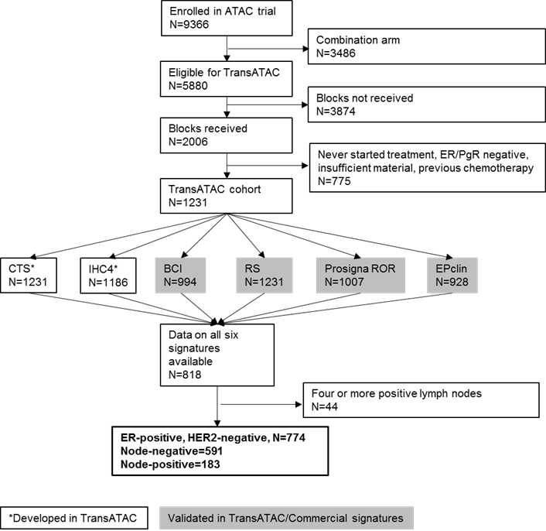

ATAC=Arimidex Tamoxifen Alone or in Combination, ER=Oestrogen Receptor, PgR=Progesterone Receptor, CTS=Clinical Treatment Score, IHC4=Immunohistochemical Score, BCI=Breast Cancer Index, RS=Recurrence Score, ROR=Risk of Recurrence Score, EPclin=EndoPredict clinical

eFigure 2: Likelihood Ratio Chi Square for prognostic information of each signature on its own (LR-χ²) and when added to CTS (∆LR-χ²) in years 0-10 for node-negative patients (left) and node-positive patients (right). Dotted line indicates significance level of 5% (LR-χ²=3.84).
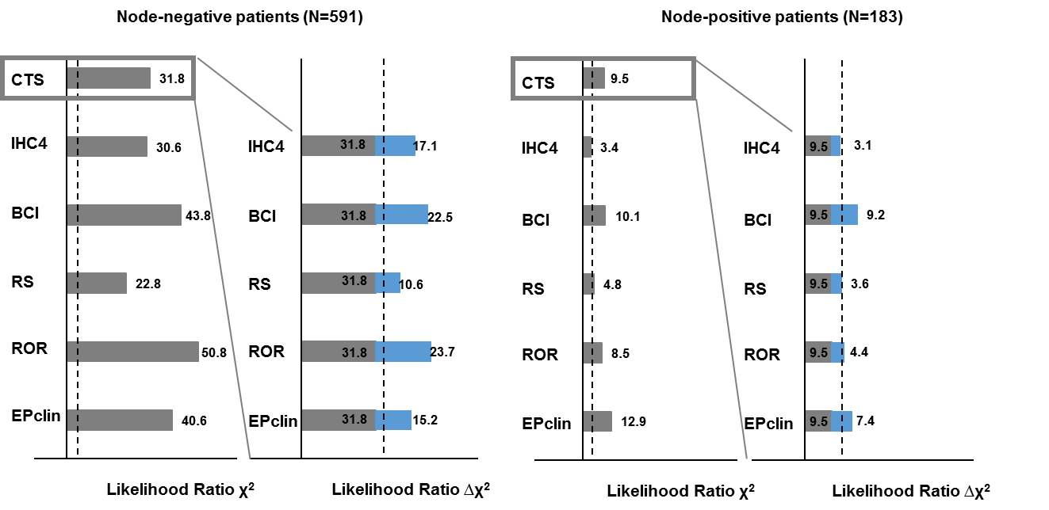
CTS=Clinical Treatment Score, IHC4=Immunohistochemical Score, BCI=Breast Cancer Index, RS=Recurrence Score, ROR=Risk of Recurrence Score,EPclin=EndoPredict clinical

eFigure 3: Likelihood Ratio Chi Square for prognostic information of each signature on its own (LR-χ²) and when added to CTS (∆LR-χ²) in years 5-10 for node-negative patients (left) and node-positive patients (right). Dotted line indicates significance level of 5% (LR-χ²=3.84).
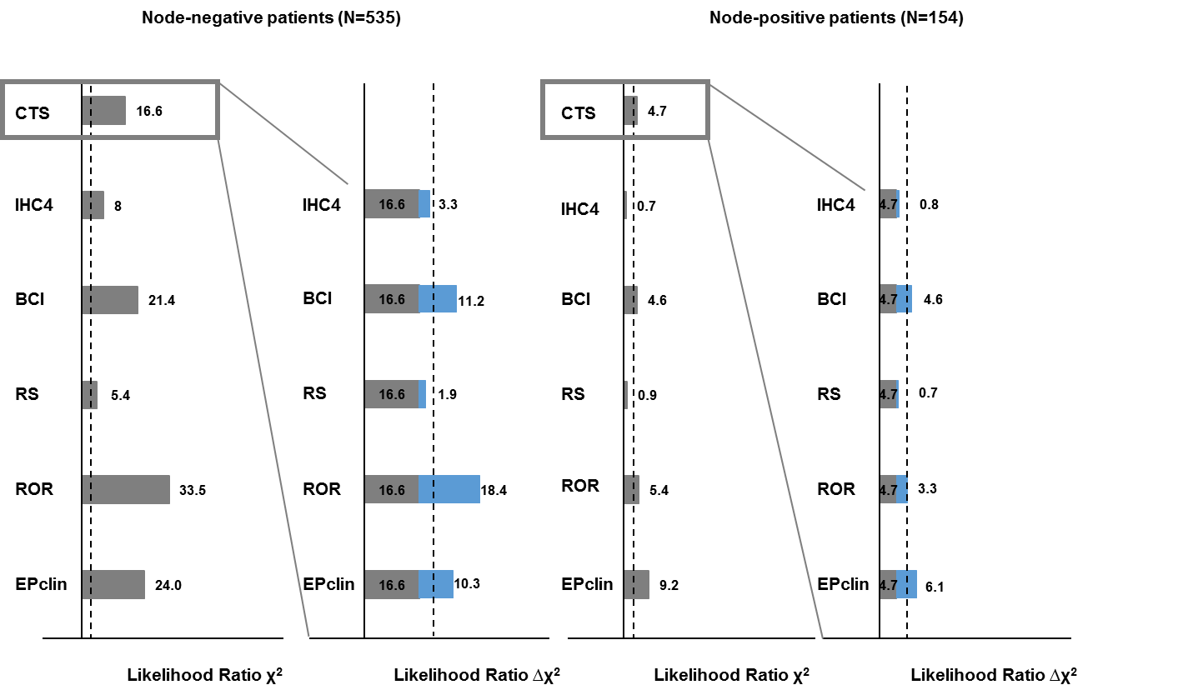
CTS=Clinical Treatment Score, IHC4=Immunohistochemical Score, BCI=Breast Cancer Index, RS=Recurrence Score, ROR=Risk of Recurrence Score,EPclin=EndoPredict clinical

