CHHiP IGRT manuscript – Supplementary information

Table S1: Margin definition and target isodose levels prescriptive to the planning
 | No IGRT and IGRT - S |  | IGRT - R
Target Isodoses | Anterior, right, left, superior, inferior | Posterior | Anterior, right, left, superior, inferior | Posterior
GTV 1 to PTV 1  (>80% median to PTV1 – PTV 2) | 10 mm | 10 mm | 6 mm | 6 mm
GTV 2 to PTV 2  (>96% median to PTV2 – PTV 3) | 10 mm | 5 mm | 6 mm | 3 mm
GTV 3 to PTV 3  (100% (+1%) median) | 5 mm | 0 mm | 3 mm | 0 mm
GTV 1 = prostate and base of SV; GTV 2 = prostate +/- base of SV; GTV 3 = prostate
Table S2: Normal tissue dose constraints
 | Prescribed Dose (Gy) |  |  | Dose (%) | Max Vol (% or cc)
 | 74Gy/37F | 60Gy/20F | 57Gy/19F | Dose (%) | Optimal | Mandatory
Rectum | 30  40  50  60  65  70  74 | 24.3  32.4  40.5  48.6  52.7  56.8  60 | 23.1  30.8  38.5  46.2  50.1  53.9  57 | 41  54  68  81  88  95  100 | 80%  70% | 60%  50%  30%  15%  3%
Bladder | 50  60  74 | 40.5  48.6  60 | 38.5  46.2  57 | 68  81  100 |  | 50%  25%  5%
Femoral heads | 50 | 40.5 | 38.5 | 68 |  | 50%
Bowel | 50 | 40.5 | 38.5 | 68 |  | 17cc
Urethral bulb | 50  60 | 40.5  48.6 | 38.5  46.2 | 68  81 | 50%  10%

Table S3: EPIC bowel domain mean and standard deviation scores from the CHHiP QoL substudy and the calculated threshold dose
EPIC | Summary |  | Function |  | Bother
EPIC | N | Mean(SD) | N | Mean(SD) | N | Mean(SD)
Bowel | 338 | 93.6 (7.79) | 334 | 93.3 (8.20) | 340 | 94.1 (9.29)
Threshold score |  | 89.7 |  | 89.2 |  | 89.5

Table S4: Treatment planning data
 | No IGRT | IGRT - S | IGRT - R
Rectal volume  Median (IQR) | 65 (59-77) | 68 (56-86) | 67 (58-85)
Rectal surface  Median (IQR) | 138 (122-152) | 136 (122-159) | 135 (115-154)
Bladder volume  Median (IQR) | 277 (200-379) | 249 (167-375) | 281 (180-386)
Bladder surface  Median (IQR) | 263 (210-343) | 274 (220-381) | 310 (227-435)
PTV1  Median (IQR) | 220 (190-252) | 194 (165-224) | 121 (98-144)
PTV2  Median (IQR) | 146 (130-171) | 139 (120-173) | 89 (70-109)
PTV3  Median (IQR) | 86 (73-102) | 84 (69-106) | 61 (47-77)

Table S5: P-values for statistical comparison of dose volume and dose surface histograms for No IGRT vs IGRT-S and IGRT-S vs IGRT-R. All doses are in equivalent dose in 2Gy fractions.
 | No IGRT vs IGRT-S | IGRT-S vs IGRT-R
Rectal DVH  5Gy  10Gy  15Gy  20Gy  25Gy  30Gy  35Gy  40Gy  45Gy  50Gy  55Gy  60Gy  65Gy  70Gy  Min  Max  Mean | <0.0001  0.035  0.032  0.281  0.412  0.101  0.027  0.022  0.049  0.281  0.949  0.732  0.999  0.450  0.008  0.383  0.097 | <0.0001  <0.0001  <0.0001  <0.0001  <0.0001  <0.0001  <0.0001  <0.0001  <0.0001  <0.0001  <0.0001  <0.0001  <0.0001  0.003  <0.0001  0.038  <0.0001
Rectal DSH  5Gy  10Gy  15Gy  20Gy  25Gy  30Gy  35Gy  40Gy  45Gy  50Gy  55Gy  60Gy  65Gy  70Gy  Min  Max  Mean | 0.082  0.057  0.110  0.884  0.686  0.185  0.046  0.023  0.019  0.158  0.873  0.517  0.598  0.501  0.007  0.551  0.174 | <0.0001  <0.0001  <0.0001  <0.0001  <0.0001  <0.0001  <0.0001  <0.0001  <0.0001  <0.0001  <0.0001  <0.0001  <0.0001  0.003  <0.0001  0.056  <0.0001
Bladder DVH  5Gy  10Gy  15Gy  20Gy  25Gy  30Gy  35Gy  40Gy  45Gy  50Gy  55Gy  60Gy  65Gy  70Gy  Min  Max  Mean | 0.876  0.640  0.491  0.350  0.280  0.331  0.308  0.324  0.306  0.351  0.364  0.422  0.477  0.279  0.305  0.337  0.334 | <0.0001  <0.0001  <0.0001  <0.0001  <0.0001  <0.0001  <0.0001  <0.0001  <0.0001  <0.0001  <0.0001  <0.0001  <0.0001  0.006  0.0003  0.027  <0.0001
Bladder DSH  5Gy  10Gy  15Gy  20Gy  25Gy  30Gy  35Gy  40Gy  45Gy  50Gy  55Gy  60Gy  65Gy  70Gy  Min  Max  Mean | <0.0001  0.996  0.727  0.434  0.290  0.206  0.238  0.283  0.346  0.416  0.553  0.667  0.588  0.359  0.206  0.330  0.475 | <0.0001  <0.0001  <0.0001  <0.0001  <0.0001  <0.0001  <0.0001  <0.0001  <0.0001  <0.0001  <0.0001  <0.0001  <0.0001  0.043  0.0001  0.067  <0.0001
Table S6: Descriptive statistics given by IGRT treatment allocation for rectum and bowel constraints
 |  |  | N  Median (IQR)  Range | N  Median (IQR)  Range | N  Median (IQR)  Range
 | Dose (%) of  prescribed Dose | Max Vol  (% or cc) | No IGRT | IGRT-S | IGRT-R
Rectum | 68  81  88  95  100 | 60%  50%  30%  15%  3% | 48  41.9 (32.0-51.2)  15.6-62.8  48  25.2 (18.1-32.5)  7.9-53.7  48  13.8 (9.8-18.1)  3.6-37.4  48  5.4 (3.2-8.9)  0.6-24.6  47  0 (0-0)  0-3.4 | 135  36.4 (27.5-47.2)  8.6-63.6  133  23.3 (16.5-31.9)  3.1-47.6  133  14.5 (10.1-20.6)  1.1-30.4  133  5.6 (2.8-7.7)  0.7-15.0  133  0 (0-0)  0-2.1 | 107  23.9 (16.2-32.3)  2.5-59.7  104  15.1 (8.3-20.5)  4.2-44.7  104  8.0 (4.4-11.9)  2.2-25.9  104  2.1 (1.0-4.0)  0.1-12.4  101  0 (0-0)  0-1.5
Bowel | 68 | 17cc | 24  0.6 (0-0)  0-95.5 | 98  0.4 (0-0)  0-33.3 | 81  0 (0-0)  0-15.8
A patient has been defined as adhering to rectum dose constraints if their maximum percentage volume was less than or equal to that specified in the table above for 68-100% of prescribed dose.
Table S7: Descriptive statistics given by IGRT treatment allocation for bladder constraints
 |  |  | N  Median (IQR)  Range | N  Median (IQR)  Range | N  Median (IQR)  Range
 | Dose (%) of  prescribed Dose | Max Vol  (%) | No IGRT | IGRT-S | IGRT-R
Bladder | 68  81  100 | 50%  25%  5% | 48  23.6 (16.6-37.3)  10.6-75.8  48  16.6 (12.0-30.6)  5.9-62.8  48  2.4 (0.8-4.0)  0.1-10.2 | 135  21.4 (15.2-31.5)  5.2-83.4  135  16.0 (10.7-23.4)  0.3-71.7  134  1.7 (0.6-3.0  0-16.7 | 107  11.9 (8.5-19.4)  3.6-43.4  105  7.9 (5.5-13.0)  0.3-33.3  104  0.2 (0-0.5)  0-5.8
A patient has been defined as adhering to bladder dose constraints if their maximum percentage volume was less than or equal to that specified in the table above for 68-100% of prescribed dose.
A total of 43 (out of 286 with data) patients missed at least one of the 3 bladder dose constraints:
19 patients missed one constraint; 16 patients missed two bladder constraints; 8 patients missed all three bladder constraints
Table S8: Number and proportion with RTOG grade>=2 toxicity at 2 years with 95% confidence intervals - by treatment group and randomisation strategy
Randomisation strategy | No IGRT v IGRT - S v IGRT - R | No IGRT v IGRT - S | IGRT - S v IGRT - R | Overall
RTOG BLADDER OR BOWEL

No IGRT  n/ N  Proportion (95%CI) | 0 / 15  0 (0-21.8)% | 2 / 30  6.7 (0.8-22.1)% | - | 2 / 46  4.3 (0.5-14.8)%
IGRT - S  n / N  Proportion (95%CI) | 0 / 10  0 (0-30.8)% | 3 / 29  10.3 (2.2-27.4)% | 4 / 86  4.7 (1.3-11.5%) | 7 / 125  5.6 (2.3-11.2)%
IGRT - R  n / N  Proportion (95%CI) | 3 / 12  25 (5.5-57.2)% | - | 1 / 91  1.1 (0.1-6.0)% | 4 / 103  3.9 (1.1-9.6)%
RTOG BOWEL

No IGRT  n / N  Proportion (95%CI) | 0 / 15  0 (0-21.8)% | 1 / 30  3.3 (0.1-17.2)% | - | 1 / 46  2.2 (0.1-11.5)%
IGRT - S  n / N  Proportion (95%CI) | 0 / 10  0 (0-30.8)% | 1 / 29  3.4 (0.1-17.8)% | 2 / 86  2.3 (0.3-8.1)% | 3 / 125  2.4 (0.5-6.9)%
IGRT - R  n / N  Proportion (95%CI) | 2 / 12  16.7 (2.1-48.4)% | - | 0 / 91  0 (0-4.0)% | 2 / 103  1.9 (0.2-6.8)%
RTOG BLADDER

No IGRT  n / N  Proportion (95%CI) | 0 / 15  0 (0-21.8) | 1 / 30  3.3 (0.1-17.2) | - | 1 / 46  2.2 (0.1-11.5)%
IGRT - S  n / N  Proportion (95%CI) | 0 / 10  0 (0-30.8)% | 2 / 29  6.8 (0.8-22.8)% | 2 / 86  2.3 (0.3-8.1)% | 4 / 125  3.2 (0.9-8.0)%
IGRT - R  n / N  Proportion (95%CI) | 1 / 12  8.3 (0.2-38.5) | - | 1 / 91  1.1 (0.1-6.0)% | 2 / 103  1.9 (0.2-6.8)%
NB. There was one patient who was originally from an IGRT-S v IGRT-R centre but was randomised to No IGRT group following the staggered closure of recruitment so the IGRT-S v IGRT-R centre changed to a No IGRT v IGRT-S v IGRT-R centre and randomised one patient to No IGRT group . This patient has been included in the overall No IGRT group figures but not in the by randomisation strategy figures.

Table S9: Hazard ratios and cumulative proportion with G1+, G2+ and G3+ bowel and bladder toxicity at 2 years assessed by RTOG, RMH and LENTSOM scoring systems
 | No IGRT v IGRT-S |  |  |  | IGRT-S v IGRT-R |  |  |  | Cumulative proportion with events at 2 years³ (95%)
 | HR (95% CI) |  |  | P¹ | HR (95% CI) |  | P¹ |  | No IGRT |  | IGRT-S |  | IGRT=RC
BOWEL
RTOG
Grade>=1  64 events² | 0.85 (0.48-1.53) |  |  | 0.596 | 0.85 (0.53-1.35) |  | 0.483 |  | 29.2 (18.4-44.2) |  | 22.0 (15.8-30.0) |  | 20.0 (13.6-29.1)
Grade>=2  21 events | 0.95 (0.34-2.67) |  |  | 0.928 | 0.68 (0.28-1.62) |  | 0.381 |  | 8.3 (3.2-20.7) |  | 8.3 (4.7-14.6) |  | 5.8 (2.6-12.4)
Grade>=3  4 events | 0.36 (0.05-2.56) |  |  | 0.287 | 0.61 (0.06-6.71) |  | 0.682 |  | 4.2 (1.1-15.7) |  | 0.8 (0.1-5.2) |  | 1.0 (0.1-6.6)
RMH
Grade>=1  112 events² | 1.06 (0.67-1.69) |  |  | 0.786 | 0.71 (0.48-1.03) |  | 0.071 |  | 43.8 (31.1-58.8) |  | 41.5 (33.7-50.4) |  | 34.2 (26.0-44.1)
Grade>=2  34 events | 1.69 (0.70-4.10) |  |  | 0.239 | 0.39 (0.18-0.83) |  | 0.012 |  | 10.4 (4.5-23.2) |  | 16.7 (11.4-24.3) |  | 6.7 (3.2-13.5)
Grade>=3  3 events | - |  |  | 0.325 | 0.79 (0.13-4.76) |  | 0.799 |  | - |  | 1.5 (0.04-5.9) |  | 1.0 (0.01-6.6)
LENTSOM
Grade>=1  120 events² | 0.99 (0.63-1.60) |  |  | 0.999 | 0.83 (0.57-1.21) |  | 0.331 |  | 45.9 (33.1-60.9) |  | 41.5 (33.7-50.4) |  | 41.1 (32.4-51.2)
Grade>=2  55 events | 1.36 (0.68-2.75) |  |  | 0.385 | 0.69 (0.40-1.19) |  | 0.181 |  | 18.8 (10.3-33.0) |  | 21.9 (15.8-30.0) |  | 16.3 (10.4-24.9)
Grade>=3  5 events | 0.54 (0.09-3.26) |  |  | 0.498 | 0.81 (0.14-4.85) |  | 0.818 |  | 4.2 (1.1-15.7) |  | 1.5 (0.4-5.9) |  | 0.9 (0.1-6.5)
BLADDER
RTOG
Grade>=1  39 events | 0.51 (0.26-0.99) |  |  | 0.044 | 0.67 (0.33-1.35) |  | 0.255 |  | 22.9 (13.4-37.6) |  | 12.9 (8.2-19.9) |  | 10.6 (6.0-18.3)
Grade>=2  14 events | 0.69 (0.21-2.29) |  |  | 0.538 | 0.62 (0.19-2.07) |  | 0.436 |  | 8.4 (3.2-20.8) |  | 4.6 (2.1-9.9) |  | 3.9 (1.5-9.9)
Grade>=3  2 events | 0.66 (0.06-7.34) |  |  | 0.735 | 0.61 (0.06-6.75) |  | 0.686 |  | 2.1 (0.3-14.2) |  | 0 |  | 1.0 (0.1-6.6)
RMH
Grade>=1  187 events | 0.95 (0.65-1.38) |  |  | 0.774 | 0.97 (0.72-1.31) |  | 0.828 |  | 62.5 (49.1-75.9) |  | 67.7 (59.7-75.4) |  | 63.6 (54.5-72.7)
Grade>=2  57 events | 1.34 (0.69-2.62) |  |  | 0.385 | 0.74 (0.44-1.22) |  | 0.231 |  | 16.7 (8.7-30.6) |  | 22.0 (15.8-30.0) |  | 19.1 (12.8-28.0)
Grade>=3  21 events | 0.90 (0.32-2.53) |  |  | 0.840 | 0.66 (0.26-1.66) |  | 0.375 |  | 10.4 (4.5-23.2) |  | 7.6 (4.2-13.7) |  | 5.8 (2.6-12.4)
LENTSOM
Grade>=1  169 events | 0.95 (0.64-1.42) |  |  | 0.815 | 1.04 (0.76-1.42) |  | 0.811 |  | 60.5 (47.1-74.2) |  | 60.4 (52.2-68.8) |  | 56.3 (47.0-65.9)
Grade>=2  81 events | 0.89 (0.51-1.56) |  |  | 0.678 | 1.01 (0.65-1.58) |  | 0.958 |  | 29.2 (18.5-44.3) |  | 28.0 (21.1-36.5) |  | 25.8 (18.5-35.4)
Grade>=3  27 events | 1.16 (0.42-3.15) |  |  | 0.776 | 0.97 (0.47-2.00) |  | 0.932 |  | 8.3 (3.2-20.7) |  | 9.2 (5.3-15.6) |  | 8.6 (4.6-15.9)
¹ Assessed using the non-stratified log-rank test; ² Total number of events reported is up to 2 years (27 months); ³ Estimated at 27 months

Table S10: Baseline characteristics for PRO responders and non-responders
 | PRO responder  N=193 | PRO non-responder  N=71 | P-value
Age at registration (years)
Median (IQR) | 71 (67-74) | 72 (65-75) | 0.83
Range | 53-80 | 55-82
Time from histological confirmation of prostate cancer to randomisation (wks)  Median (IQR)  Range | 17 (13-25)  4-278 | 19 (13-28)  6-126 | 0.98
T stage (clinical assessment)
T1a/T1b/T1c/T1x | 76 (39) | 21 (30) | 0.10
T2a/T2b/T2c/T2x | 108 (56) | 37 (52)
T3a/T3x | 9 (5) | 13 (18)
Grading (Gleason score)
1 (3+3) | 53 (27) | 21 (30) | 0.45
2 (3+4)  3 (4+3) | 98 (51)  38 (20) | 37 (52)  13 (18)
4 (4+4, 3+5, 5+3) | 4 (2) | 0
PSA (pre-hormone treatment) (ng/ml)
Median (IQR) | 9.2 (6.6-12.5) | 9.1 (7.1-11.6)
Mean (SD) | 10.1 (4.5) | 0.5-18.6
PSA (ng/ml)
0.0<5 | 17 (9) | 8 (11) | 0.35
5.0<10 | 92 (48) | 35 (49)
10.0<20 | 80 (41) | 28 (39)
20.0<50 | 4 (2) | 0
NCCN Risk group
Low | 24 (12) | 9 (13) | 0.67
Medium | 153 (79) | 54 (76)
High | 16 (8) | 8 (11)
CHHiP treatment allocation  No IGRT  IGRT-S  IGRT-R | 29 (15)  89 (46)  75 (39) | 10 (13)  30 (42)  31 (44) | 0.55
Co-morbidities  Diabetes  Hypertension  Inflammatory bowel disease or diverticular disease  Previous pelvic surgery  Symptomatic haemorrhoids (12 months prior to randomisation)  Previous TURP | 20 (11)  73 (41)  10 (6)  16 (9)  12 (7)  19 (11 | 8 (11)  25 (39)  2 (3)  4 (7)  3 (5)  3 (5) | 0.82  0.88  0.74  0.79  0.76  0.21

Table S11: Percentage volume and surface receiving each dose level according to Vaizey scores categorised as tertiles (Ter1=Vaizey score 0-4; Ter2=Vaizey total 5-7; Ter3=Vaizey score 7-19). All doses are equivalent dose in 2Gy fractions.

 | 0 Gy | 5 Gy | 10 Gy | 15 Gy | 20 Gy | 25 Gy | 30 Gy | 35 Gy | 40 Gy | 45 Gy | 50 Gy | 55 Gy | 60 Gy | 65 Gy | 70 Gy | Volume | Min | Max | Mean
Dose Volume Histogram
Ter1 | 100 | 89.1 | 86.1 | 81.8 | 72.2 | 57.3 | 42.6 | 34.7 | 30.1 | 26.1 | 22.5 | 17.3 | 10.9 | 5.4 | 0.3 | 65.8 | 1.3 | 71.5 | 31.7
Ter2 | 100 | 90.3 | 85.8 | 81.3 | 69.9 | 57.1 | 46.5 | 39.2 | 32.9 | 28.6 | 23.4 | 17.1 | 9.3 | 3.7 | 0.1 | 65.6 | 1.1 | 70.6 | 31.7
Ter3 | 100 | 89.5 | 85.0 | 81.7 | 73.7 | 57.6 | 43.2 | 36.2 | 30.6 | 26.3 | 22.0 | 17.7 | 11.1 | 5.5 | 0.3 | 69.2 | 1.2 | 71.1 | 31.8
Dose Surface Histogram
Ter1 | 100 | 88.0 | 83.2 | 79.9 | 67.6 | 52.6 | 40.2 | 35.3 | 31.9 | 29.4 | 26.7 | 21.6 | 16.2 | 11.5 | 2.9 | 135.7 | 1.3 | 71.7 | 32. 4
Ter2 | 100 | 88.6 | 84.6 | 78.5 | 66.6 | 53.7 | 42.1 | 36.3 | 32.9 | 30.0 | 26.8 | 22.4 | 16.1 | 10.0 | 0.6 | 129.4 | 1.1 | 70.7 | 32.7
Ter3 | 100 | 87.8 | 82.7 | 77.6 | 67.0 | 51.0 | 41.1 | 35.7 | 31.5 | 28.6 | 25.0 | 21.2 | 16.7 | 11.3 | 2.1 | 138.5 | 1.2 | 71.3 | 31.6

Figure S1: Boxplots showing along the top row the dose volume histograms for patients whose EPIC bowel (A) and urinary (B) domain scores were above or below the defined thresholds. The dose surface histograms are shown along the bottom row for those patients whose EPIC bowel (A) and urinary (B) domain scores were above or below the defined thresholds. All doses are equivalent dose in 2Gy fractions.

(A)
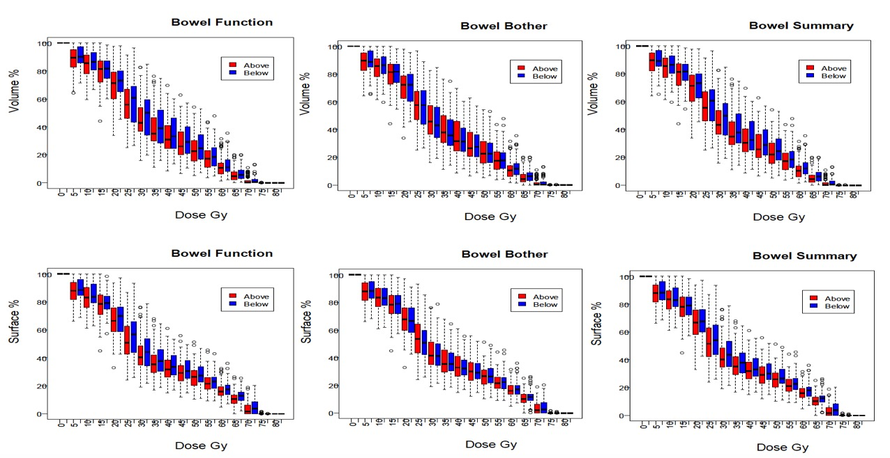

(B)
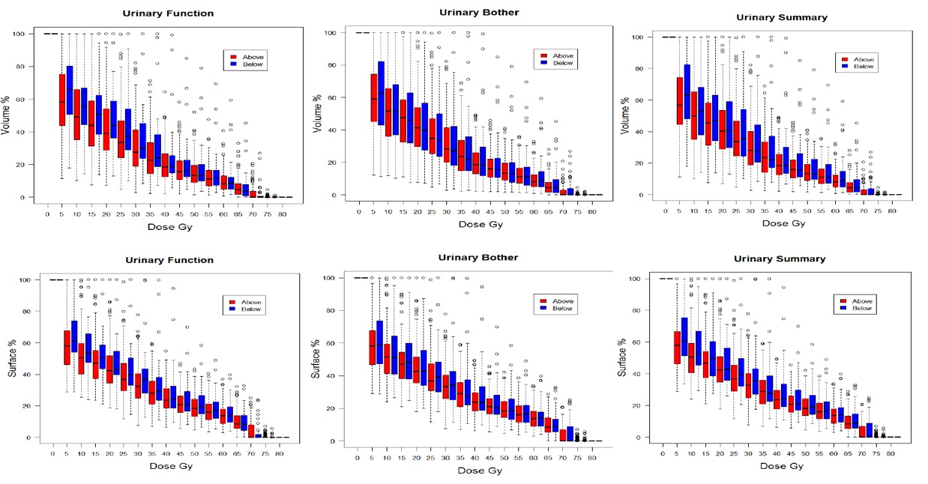

Table S12: Efficacy data by IGRT substudy group
 | No IGRT  N=48 | IGRT – S  N=137 | IGRT – R  N=108
Biochemical/clinical failure free survival  N (events)  5yr KM estimate (95% CI) | 4 (8)  91.1 (77.9-96.6) | 20 (15)  85.2 (77.7-90.3) | 9 (8)  93.1 (86.1-96.7)
Recommenced androgen deprivation  n (%) | 0 | 11 (8) | 3 (3)
Local recurrence  n (%) | 0 | 7 (5) | 2 (2)
Lymph node/pelvic recurrence  n (%) | 1 (2) | 5 (4) | 1 (1)
Distant recurrence  n (%) | 1 (2) | 5 (4) | 1 (1)
Died  n (%)  Cause of death:  Prostate cancer related  Not related to prostate cancer  Unknown | 5 (10)  0  4  1 | 15 (11)  3  12  0 | 7 (7)  0  7  0
NB. Events are not mutually exclusive

Figure S2 Kaplan Meier for biochemical/clinical failure free survival by IGRT substudy group
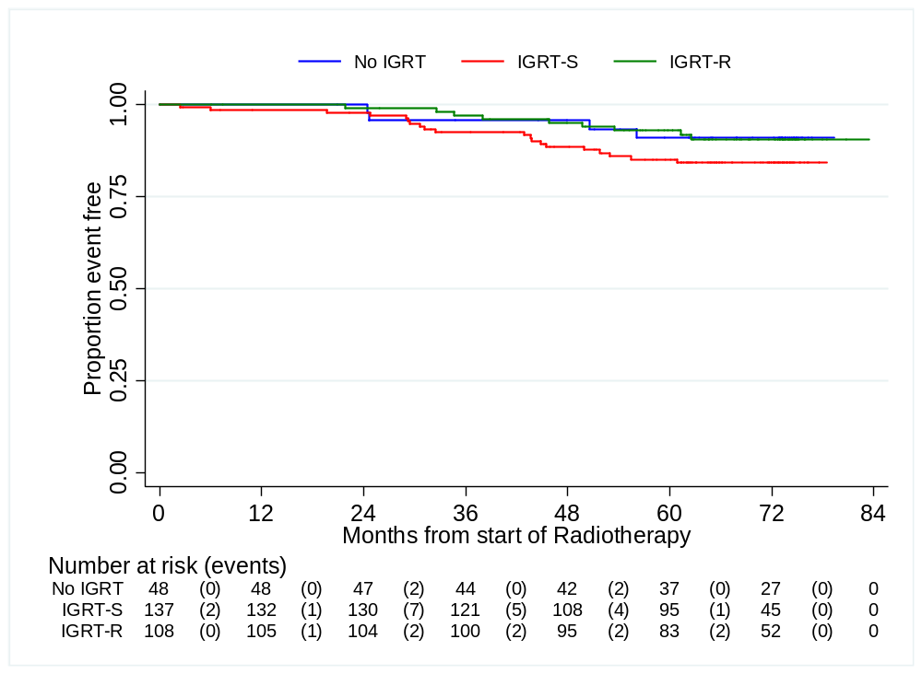

Radiotherapy Quality Assurance
IGRT quality assurance (QA) programme was developed as an adjunct to the main radiotherapy trial QA to accredit centres to participate in the CHHiP IGRT substudy. The primary aim of the QA was to audit compliance with the IGRT requirements of the trial protocol.
The QA exercises comprised:
- Completion of a process document, to review and verify the centres’ IGRT techniques and processes
- Measurements to assess the accuracy of the imaging and corrections applied (accuracy of couch repositioning and kV/MV isocentre alignments).
- Collection of daily isocentre displacement data for all patients, to assess the feasibility of utilising data from multiple manufacturers’ equipment.

Equipment | No. of centres | Imaging techniques
Elekta XVI | 3 | kV cone beam 360°  kV orthogonal images
Varian OBI | 8 | kV cone beam 360°  kV orthogonal images
Elekta a-Si portal imager | 1 | MV orthogonal images
Varian a-Si portal imager | 5 | MV orthogonal images
Somatom CT on rails | 1 | kV CT scan
Tomotherapy | 1 | MV CT scan
ExacTrac | 1 | kV orthogonal images

Table 1: Imaging procedures used by CHHiP IGRT centres
7 centres performed automatic couch repositioning, with a zero tolerance. The other 12 centres corrected for any set-up errors ≥2mm. 6 centres performed post-correction imaging, and 2 centres performed post-treatment imaging.

Issues identified during the QA process for 19 centres approved for the CHHiP IGRT substudy included:
- Whether to permit the use of a planning MR scan, fused with the planning CT images, for outlining the prostate CTV. Prostates outlined using MR imaging often have a smaller volume than those outlined using CT images. This was potentially an issue for the CHHiP IGRT study since the experimental arm used reduced PTV margins, and outlining the CTV using MR could have the effect of reducing the effective margin still further. A recommendation was therefore made that MR fusion for prostate outlining would be permitted for those few centres who had already introduced MR/CT fusion into their routine practice, but that the prostate apex should be very adequately outlined.
- Whether an action level for post-correction images should be applied. Post-correction images were mandatory for centres using manual couch repositioning equipment to ensure that the correction was applied in the right direction. No specific action level was set in the protocol, whereas an action level of 2mm was applied for the pre-treatment imaging.
- Imaging doses reported for different imaging techniques varied significantly in both value and dose descriptor, which made them difficult to interpret and compare.
- Set up displacements were not displayed or stored consistently between manufacturers. Some systems reported the physical couch shift required (e.g. -0.5cm vertical), while others converted this to a displacement relative to the patient position (e.g. 0.5cm anterior). Some systems did not store this information, hence these data were not available for retrospective analysis. Information was not recorded on the timing of the image (i.e. pre- or post-correction), or whether systematic shifts were applied.
- The level of IGRT experience had an impact of the number and grade of radiographers who were performing the on-line image registration in each centre.

