Glioma risk associated with extent of estimated European genetic ancestry in African-Americans and Hispanics
Quinn T. Ostrom, Kathleen M. Egan, L. Burt Nabors, Travis Gerke, Reid C. Thompson, Jeffrey J. Olson, Renato LaRocca, Sajeel Chowdhary, Jeanette E. Eckel-Passow, Georgina Armstrong, John K. Wiencke, Jonine L. Bernstein, Elizabeth B. Claus, Dora Il'yasova, Christoffer Johansen, Daniel H. Lachance, Rose K. Lai, Ryan T. Merrell, Sara H. OlsonError: Reference source not found, Siegal Sadetzki, Joellen M. Schildkraut, Sanjay Shete, Richard S. Houlston, Robert B. Jenkins, Margaret R. Wrensch, Beatrice MelinError: Reference source not found, Christopher I. Amos, Jason T. Huse, Jill S. Barnholtz-Sloan*, Melissa L. Bondy*
* These authors jointly supervised this work and are joint senior authors
Supplementary Notes
Supplementary Note 1. Statistical power calculations for genome-wide analyses of local ancestry 3
Supplementary Note 2. Statistical power calculations for single SNP analyses of 25 previously identified risk loci 3

Supplementary Tables
Supplementary Table 1. Odds ratios, 95% confidence intervals, and p-values for SNPs previously identified as being associated with glioma in European ancestry populations in Europeans (>=80% global European Ancestry), African-Americans (>=40% global African ancestry), and Hispanics (>=15% global American ancestry). 4
Supplementary Table 2. Odds ratios, 95% confidence intervals, and p-values for SNPs previously identified as being associated with glioma and nominally significant SNPs within +/- 500kb in Europeans (>=80% global European Ancestry), African-Americans (>=40% global African ancestry), and Hispanics (>=15% global American ancestry). 7

Supplementary Figures
Supplementary Figure 1. 1st and 2nd Principal Components of reference populations (AFR=1000 Genomes project African Continental Population, AMR=1000 Genomes project American Continental Population, EAS=1000 genomes project East Asian Continental population, EUR=1000 genomes project European continental population.) , and GICC and GliomaSE individuals used for ancestry estimation (Self-identified African Americans and Hispanics from GliomaSE, and individuals with European ancestry estimated to be <80% by FastPop in GICC), by study status and population for A) GICC and B) GliomaSE 10
Supplementary Figure 2. Global ancestry estimates by self-identified race/ethnicity group for A) GliomaSE ((Self-identified African Americans and Hispanics), and B) GICC (individuals with European ancestry estimated to be <80% by FastPop in GICC) 11
Supplementary Figure 3. Distribution of estimated proportion of global African ancestry in self-identified African-Americans, and of estimated proportion of native American ancestry in self-identified Hispanics 12
Supplementary Figure 4. Distributions and p-values for A) global European Ancestry and B) global African Ancestry overall, and by study site for C) global European Ancestry and D) global African Ancestry, among those for those self-identified as African American 13
Supplementary Figure 5. Distributions and p-values for global European Ancestry and global African Ancestry by histology for those self-identified as African American 14
Supplementary Figure 6. Distributions and p-values for A) global European Ancestry and B) global Native American Ancestry overall, and by study site for C) global European Ancestry and D) global Native American Ancestry, among those self-identified as Hispanic 15
Supplementary Figure 7. Distributions and p-values for global European Ancestry and global Native American Ancestry by histology for those self-identified as Hispanic 16
Supplementary Figure 8. -log10(p) values for single SNP associations in individuals with >=40% global African ancestry (AFR_{≥0.4} ) for selected regions on A) chromosome 7, B) chromosome 11, and C) chromosome 20, and individuals with >=15% global Native American ancestry (AMR_{≥0.15}) for selected regions one D) chromosome 8, E) chromosome 12, and F) chromosome 20. 17

Supplementary Note 1. Statistical power calculations for genome-wide analyses of local ancestry
Power was calculated as described by Shriner, et al.¹ Effect numbers of independent tests per individual and per chromosome was estimated using the autocorrelation method described in Sobota, et al.² in R 3.5.0 using R package coda. Summed across autosomes for each individual and averaged across individuals, the effective number of tests for admixture mapping was 299.15 for African Americans (≥40% African ancestry) and 228.82 for Hispanics (≥15% Native American ancestry). Based on a Bonferroni correction, the genome-wide significance for admixture mapping was p<1.67x10⁻⁴ (α=0.05/300) for the ≥40% African ancestry set and p<2.17x10⁻⁴ (α=0.05/230) for the ≥15% Native American ancestry set. Power to detect a true association, assuming equal number of cases and controls, is shown in Table A for the 40% African ancestry set, and Table B for the ≥15% Native American ancestry set.

Table A. Number of cases required to achieve 80% power at p<1.67x10⁻⁴ significance level, by admixture proportion, penetrance, and difference in allele frequencies
Admixture proportion | Penetrance | MAFpopulation1 / MAFpopulation2
Admixture proportion | Penetrance | 0.1/0.4 (4x RAF) | 0.1/0.5 (5x RAF) | 0.1/0.8 (8x RAF) | 0.2/0.5 (2.5x RAF) | 0.2/0.8 (4x RAF) | 0.3/0.6 (2x RAF) | 0.3/0.9 (3x RAF) | 0.4/0.8 (2x RAF) | 0.5/0.8 (1.6x RAF)
0.4 | 2 | 0.0281 | 0.0764 | 0.4363 | 0.0209 | 0.2220 | 0.0160 | 0.1720 | 0.0329 | 0.0102
0.4 | 4 | 0.5292 | 0.8312 | 0.9989 | 0.3151 | 0.9503 | 0.1870 | 0.8522 | 0.2885 | 0.0738
0.4 | 6 | 0.8906 | 0.9890 | 1.0000 | 0.6202 | 0.9971 | 0.3758 | 0.9704 | 0.4869 | 0.1345
0.8 | 2 | 0.0073 | 0.0165 | 0.0867 | 0.0058 | 0.0425 | 0.0047 | 0.0334 | 0.0083 | 0.0034
0.8 | 4 | 0.1101 | 0.2329 | 0.6348 | 0.0604 | 0.3587 | 0.0361 | 0.2476 | 0.0551 | 0.0160
0.8 | 6 | 0.2800 | 0.4864 | 0.8587 | 0.1372 | 0.5783 | 0.0731 | 0.4057 | 0.0990 | 0.0268

Table B. Power to detect an association for 210 cases and controls, at p<2.17x10⁻⁴ significance level, by admixture proportion, penetrance, and difference in allele frequencies
Admixture proportion | Penetrance | MAFpopulation1 / MAFpopulation2
Admixture proportion | Penetrance | 0.1/0.4 (4x RAF) | 0.1/0.5 (5x RAF) | 0.1/0.8 (8x RAF) | 0.2/0.5 (2.5x RAF) | 0.2/0.8 (4x RAF) | 0.3/0.6 (2x RAF) | 0.3/0.9 (3x RAF) | 0.4/0.8 (2x RAF) | 0.5/0.8 (1.6x RAF)
0.15 | 2 | 0.0200 | 0.0500 | 0.3200 | 0.0100 | 0.1500 | 0.0100 | 0.1100 | 0.0200 | 0.0100
0.15 | 4 | 0.4000 | 0.7300 | 1.0000 | 0.2200 | 0.9000 | 0.1300 | 0.7600 | 0.2000 | 0.0500
0.15 | 6 | 0.8100 | 0.9700 | 1.0000 | 0.4900 | 0.9900 | 0.2700 | 0.9400 | 0.3600 | 0.0900
0.30 | 2 | 0.0400 | 0.1000 | 0.5100 | 0.0300 | 0.2700 | 0.0200 | 0.2100 | 0.0400 | 0.0100
0.30 | 4 | 0.6100 | 0.8900 | 1.0000 | 0.3800 | 0.9800 | 0.2300 | 0.9100 | 0.3500 | 0.0900
0.30 | 6 | 0.9400 | 1.0000 | 1.0000 | 0.7000 | 1.0000 | 0.4500 | 0.9900 | 0.5700 | 0.1700

Supplementary Note 2. Statistical power calculations for single SNP analyses of 25 previously identified risk loci
Power was calculated using the GAS power calculator (http://csg.sph.umich.edu/abecasis/cats/gas_power_calculator/index.html) using the CATS algorithm Estimates are based on an additive disease model with population-level glioma prevalence estimated to be 20.29 per 100,000 (based on Zhang et al.⁷), and a significance threshold of p<0.002 (Bonferroni adjustment for 25 tests). Power to detect a true association, assuming equal number of cases and controls, is shown in Table C for the 40% African ancestry set, and Table D for the ≥15% Native American ancestry set.

Table C. Estimated power to detect a true association at p<0.002 significance level with 190 cases and 180 controls, by MAF and effect size
MAF | OR_{het}/OR_{homo}
MAF | 1.3/1.6 (0.77/0.63) | 1.5/2.0 (0.67/0.50) | 2.0/3.0 (0.50/0.33) | 2.5/4.0 (0.40/0.25) | 3.0/5.0 (0.33/0.20)
0.05 | 0.0110 | 0.0360 | 0.2130 | 0.5130 | 0.7700
0.10 | 0.0230 | 0.0850 | 0.4600 | 0.8160 | 0.9580
0.20 | 0.0460 | 0.1740 | 0.6930 | 0.9400 | 0.9910
0.30 | 0.0620 | 0.2230 | 0.7440 | 0.9480 | 0.9900
0.40 | 0.0680 | 0.2310 | 0.7180 | 0.9230 | 0.9780
0.50 | 0.0650 | 0.2090 | 0.6410 | 0.8600 | 0.9420

Table D. Estimated power to detect a true association at p<0.002 significance level with 210 cases and 190 controls, by MAF and effect size
MAF | OR_{het}/OR_{homo}
MAF | 1.3/1.6 (0.77/0.63) | 1.5/2.0 (0.67/0.50) | 2.0/3.0 (0.50/0.33) | 2.5/4.0 (0.40/0.25) | 3.0/5.0 (0.33/0.20)
0.05 | 0.0120 | 0.0400 | 0.2420 | 0.5670 | 0.8170
0.10 | 0.0260 | 0.0960 | 0.5090 | 0.8580 | 0.9730
0.20 | 0.0520 | 0.1970 | 0.7420 | 0.9600 | 0.9950
0.30 | 0.0700 | 0.2510 | 0.7890 | 0.9650 | 0.9950
0.40 | 0.0760 | 0.2600 | 0.7650 | 0.9450 | 0.9870
0.50 | 0.0730 | 0.2360 | 0.6900 | 0.8930 | 0.9600

References
1. Shriner D, Adeyemo A, Rotimi CN. Joint Ancestry and Association Testing in Admixed Individuals. PLoS Comput Biol 2011;7: e1002325.
2. Sobota RS, Shriner D, Kodaman N, Goodloe R, Zheng WEI, Gao Y-T, Edwards TL, Amos CI, Williams SM. Addressing population-specific multiple testing burdens in genetic association studies. Ann Hum Genet 2015;79: 136-47.
3. Plummer M, Best N, Cowles K, Vines K. CODA: Convergence Diagnosis and Output Analysis for MCMC. R News 2006;6: 7-11.
4. R Core Team. R: A language and environment for statistical computing Vienna, Austria: R Foundation for Statistical Computing, 2018.
5. Johnson JL, Abecasis GR. GAS Power Calculator: web-based power calculator for genetic association studies. bioRxiv 2017.
6. Skol AD, Scott LJ, Abecasis GR, Boehnke M. Joint analysis is more efficient than replication-based analysis for two-stage genome-wide association studies. Nature genetics 2006;38: 209-13.
7. Zhang AS, Ostrom QT, Kruchko C, Rogers L, Peereboom DM, Barnholtz-Sloan JS. Complete prevalence of malignant primary brain tumors registry data in the United States compared with other common cancers, 2010. Neuro Oncol 2017;19: 726-35.
8. Melin BS, Barnholtz-Sloan JS, Wrensch MR, Johansen C, Il'yasova D, Kinnersley B, Ostrom QT, Labreche K, Chen Y, Armstrong G, Liu Y, Eckel-Passow JE, et al. Genome-wide association study of glioma subtypes identifies specific differences in genetic susceptibility to glioblastoma and non-glioblastoma tumors. Nature genetics 2017;49: 789-94.
9. Jacobs DI, Walsh KM, Wrensch M, Wiencke J, Jenkins R, Houlston RS, Bondy M, Simon M, Sanson M, Gousias K, Schramm J, Labussiere M, et al. Leveraging ethnic group incidence variation to investigate genetic susceptibility to glioma: a novel candidate SNP approach. Front Genet 2012;3: 203.
10. Yu X, Sun NR, Jang HT, Guo SW, Lian MX. Associations between EGFR gene polymorphisms and susceptibility to glioma: a systematic review and meta-analysis from GWAS and case-control studies. Oncotarget 2017;8: 86877-85.
11. Song X, Zhou K, Zhao Y, Huai C, Zhao Y, Yu H, Chen Y, Chen G, Chen H, Fan W, Mao Y, Lu D. Fine mapping analysis of a region of 20q13.33 identified five independent susceptibility loci for glioma in a Chinese Han population. Carcinogenesis 2012;33: 1065-71.

Supplementary Table 1. Odds ratios, 95% confidence intervals, and p-values for SNPs previously identified as being associated with glioma in European ancestry populations in Europeans (>=80% global European Ancestry), African-Americans (>=40% global African ancestry), and Hispanics (>=15% global American ancestry).
Locus | Associated Gene | SNP RSID  Position | Histology | 1000G Allele  frequencies |  |  |  | >80% Global European Ancestry (Melin, et al. ⁸)  ~12,000 Cases (~6,100 GBM, ~5,800 non-GBM)  ~18,000 Controls |  |  |  |  | ≥40% global African ancestry (GICC/GliomaSE) (AFR_{≥0.4})  193 Cases (114 GBM, 74 non-GBM)  180 Controls |  |  |  |  |  |  |  | ≥15% global American ancestry (GICC) (AMR_{≥0.15})  211 Cases (97 GBM, 108 non-GBM)  185 Controls
 |  |  |  | AFR | AMR | EAS | EUR | Cases MAFª | Controls MAFª | P | OR  (95%CI) | P_{het} | Cases RAF |  | Controls RAF |  | P | OR  (95%CI) |  | P_{het} | Cases RAFª | Controls RAFª |  | P | OR  (95%CI)
 |  |  |  |  |  |  |  |  |  |  |  |  | GICC | Glioma SE | GICC | Glioma SE
1p31.3 | RAVER2 | rs12752552  65229299 | All glioma | 0.166 | 0.094 | 0.000 | 0.130 | 0.109 | 0.136 | 3.33x10⁻⁹ | 0.85  (0.80-0.90) | 0.0638 | 0.186 | 0.186 | 0.190 | 0.146 | 0.7196 |  | 1.08  (0.72-1.60) | 0.4429 | 0.089 | 0.089 | 0.9863 |  | 1.00  (0.60-1.65)
 |  | rs12752552  65229299 | GBM | -- | -- | -- | -- | 0.104 | 0.136 | 4.98x10⁻¹⁰ | 0.81  (0.76-0.87) | 0.0897 | 0.188 | 0.173 | 0.190 | 0.146 | 0.7502 |  | 1.08  (0.67-1.74) | 0.4193 | 0.107 | 0.089 | 0.4581 |  | 1.26  (0.69-2.30)
 |  | rs12752552  65229299 | Non-GBM | -- | -- | -- | -- | 0.117 | 0.136 | 0.0020 | 0.90  (0.84-0.96) | 0.3760 | 0.170 | 0.207 | 0.190 | 0.146 | 0.9238 |  | 1.03  (0.60-1.76) | 0.3852 | 0.073 | 0.089 | 0.3533 |  | 0.73  (0.38-1.41)
1q32.1 | MDM4 | rs4252707  204508147 | All glioma | 0.124 | 0.095 | 0.402 | 0.220 | 0.205 | 0.183 | 2.68x10⁻⁷ | 1.12  (1.07-1.17) | 0.0436 | 0.127 | 0.135 | 0.124 | 0.139 | 0.9771 |  | 0.99  (0.64-1.55) | 0.9537 | 0.124 | 0.122 | 0.9365 |  | 1.02  (0.65-1.59)
 |  | rs4252707  204508147 | GBM | -- | -- | -- | -- | 0.196 | 0.183 | 0.0161 | 1.07  (1.01-1.13) | 0.5535 | 0.144 | 0.138 | 0.124 | 0.139 | 0.7487 |  | 1.09  (0.64-1.85) | 0.7489 | 0.130 | 0.122 | 0.7169 |  | 1.11  (0.64-1.92)
 |  | rs4252707  204508147 | Non-GBM | -- | -- | -- | -- | 0.218 | 0.183 | 3.50x10⁻⁹ | 1.19  (1.12-1.26) | 0.0016 | 0.117 | 0.129 | 0.124 | 0.139 | 0.8640 |  | 0.95  (0.52-1.74) | 0.8441 | 0.122 | 0.122 | 0.7752 |  | 0.92  (0.54-1.58)
1q44 | AKT3 | rs12076373  243851947 | All glioma | 0.306 | 0.223 | 0.317 | 0.163 | 0.146 | 0.163 | 0.0005 | 0.92  (0.87-0.96) | 0.0152 | 0.252 | 0.245 | 0.275 | 0.281 | 0.3919 |  | 0.85  (0.59-1.23) | 0.7667 | 0.181 | 0.199 | 0.5518 |  | 0.89  (0.62-1.29)
 |  | rs12076373  243851947 | GBM | -- | -- | -- | -- | 0.159 | 0.163 | 0.9030 | 1.00  (0.95-1.07) | 0.0208 | 0.208 | 0.276 | 0.275 | 0.281 | 0.2330 |  | 0.76  (0.49-1.19) | 0.4086 | 0.217 | 0.199 | 0.5120 |  | 1.17  (0.74-1.84)
 |  | rs12076373  243851947 | Non-GBM | -- | -- | -- | -- | 0.129 | 0.163 | 2.14x10⁻¹⁰ | 0.81  (0.76-0.86) | 0.5529 | 0.299 | 0.196 | 0.275 | 0.281 | 0.5408 |  | 0.86  (0.52-1.41) | 0.1225 | 0.151 | 0.199 | 0.1986 |  | 0.74  (0.47-1.17)
2q33.3 | C2orf80 | rs7572263  209051586 | All glioma | 0.383 | 0.180 | 0.028 | 0.244 | 0.212 | 0.229 | 1.09x10⁻⁵ | 0.90  (0.86-0.94) | 0.0329 | 0.340 | 0.311 | 0.354 | 0.370 | 0.4819 |  | 0.88  (0.63-1.25) | 0.5951 | 0.145 | 0.188 | 0.1187 |  | 0.74  (0.51-1.08)
 |  | rs7572263  209051586 | GBM | -- | -- | -- | -- | 0.218 | 0.229 | 0.0277 | 0.94  (0.90-0.99) | 0.0394 | 0.355 | 0.308 | 0.354 | 0.370 | 0.6283 |  | 0.90  (0.59-1.37) | 0.3746 | 0.150 | 0.188 | 0.2418 |  | 0.76  (0.48-1.20)
 |  | rs7572263  209051586 | Non-GBM | -- | -- | -- | -- | 0.199 | 0.229 | 6.64x10⁻¹⁰ | 0.84  (0.79-0.89) | 0.8217 | 0.322 | 0.316 | 0.354 | 0.370 | 0.7157 |  | 0.92  (0.58-1.45) | 0.6909 | 0.143 | 0.188 | 0.2767 |  | 0.77  (0.48-1.23)
3p14.1 | LRIG1 | rs11706832  66502981 | All glioma | 0.088 | 0.324 | 0.192 | 0.456 | 0.492 | 0.475 | 9.40x10⁻⁶ | 1.08  (1.05-1.12) | 0.4161 | 0.189 | 0.216 | 0.184 | 0.167 | 0.6062 |  | 1.11  (0.75-1.63) | 0.4773 | 0.313 | 0.286 | 0.4334 |  | 1.13  (0.84-1.52)
 |  | rs11706832  66502981 | GBM | -- | -- | -- | -- | 0.487 | 0.475 | 0.1604 | 1.03  (0.99-1.08) | 0.7750 | 0.186 | 0.173 | 0.184 | 0.167 | 0.8733 |  | 1.04  (0.65-1.65) | 0.7009 | 0.304 | 0.286 | 0.6673 |  | 1.08  (0.75-1.57)
 |  | rs11706832  66502981 | Non-GBM | -- | -- | -- | -- | 0.501 | 0.475 | 8.66x10⁻⁹ | 1.15  (1.09-1.20) | 0.2250 | 0.192 | 0.285 | 0.184 | 0.167 | 0.2886 |  | 1.33  (0.79-2.24) | 0.3463 | 0.319 | 0.286 | 0.4891 |  | 1.14  (0.79-1.64)
5p15.33 | TERT | rs10069690  1279790 | All glioma | 0.662 | 0.221 | 0.169 | 0.276 | 0.338 | 0.264 | 2.32x10⁻⁶⁶ | 1.45  (1.39-1.51) | 0.0560 | 0.620 | 0.640 | 0.572 | 0.538 | 0.0816 |  | 1.31  (0.97-1.78) | 0.3883 | 0.284 | 0.194 | 0.0056 |  | 1.56  (1.14-2.13)
 |  | rs10069690  1279790 | GBM | -- | -- | -- | -- | 0.367 | 0.264 | 4.99x10⁻⁷⁵ | 1.62  (1.54-1.70) | 0.4002 | 0.610 | 0.691 | 0.572 | 0.538 | 0.0564 |  | 1.43  (0.99-2.06) | 0.1499 | 0.253 | 0.194 | 0.1264 |  | 1.37  (0.91-2.06)
 |  | rs10069690  1279790 | Non-GBM | -- | -- | -- | -- | 0.302 | 0.264 | 8.57x10⁻¹⁸ | 1.28  (1.21-1.36) | 0.2261 | 0.625 | 0.560 | 0.572 | 0.538 | 0.3849 |  | 1.20  (0.80-1.81) | 0.9495 | 0.314 | 0.194 | 0.0083 |  | 1.69  (1.14-2.48)
7p11.2 | EGFR | rs75061358  54916280 | All glioma | 0.005 | 0.058 | 0.001 | 0.099 | 0.102 | 0.076 | 4.99x10⁻²⁷ | 1.42  (1.33-1.52) | 0.9728 | 0.027 | 0.027 | 0.027 | 0.028 | 0.9564 |  | 1.03  (0.36-2.93) | 0.8184 | 0.072 | 0.056 | 0.2725 |  | 1.40  (0.77-2.55)
 |  | rs75061358  54916280 | GBM | -- | -- | -- | -- | 0.112 | 0.076 | 3.21x10⁻³³ | 1.62  (1.50-1.75) | 0.8671 | 0.031 | 0.011 | 0.027 | 0.028 | 0.9869 |  | 0.99  (0.25-3.93) | 0.3111 | 0.074 | 0.056 | 0.5168 |  | 1.29  (0.60-2.79)
 |  | rs75061358  54916280 | Non-GBM | -- | -- | -- | -- | 0.092 | 0.076 | 3.55x10⁻⁸ | 1.28  (1.17-1.39) | 0.2019 | 0.025 | 0.053 | 0.027 | 0.028 | 0.7466 |  | 1.25  (0.32-4.89) | 0.5727 | 0.075 | 0.056 | 0.2750 |  | 1.51  (0.72-3.15)
7p11.2 | EGFR | rs723527  55134872 | All glioma | 0.738 | 0.666 | 0.973 | 0.427 | 0.370 | 0.427 | 6.45x10⁻¹⁷ | 0.86  (0.83-0.89) | 0.0996 | 0.549 | 0.650 | 0.663 | 0.686 | 0.0118 |  | 0.66  (0.48-0.91) | 0.4225 | 0.592 | 0.623 | 0.3534 |  | 0.87  (0.66-1.16)
 |  |  | GBM | -- | -- | -- | -- | 0.351 | 0.427 | 2.31x10⁻²³ | 0.80  (0.76-0.83) | 0.5971 | 0.518 | 0.646 | 0.663 | 0.686 | 0.0119 |  | 0.62  (0.42-0.90) | 0.3217 | 0.593 | 0.623 | 0.5929 |  | 0.91  (0.64-1.29)
 |  |  | Non-GBM | -- | -- | -- | -- | 0.393 | 0.427 | 6.21x10⁻⁴ | 0.92  (0.88-0.96) | 0.0521 | 0.590 | 0.656 | 0.663 | 0.686 | 0.3501 |  | 0.81  (0.51-1.27) | 0.4502 | 0.588 | 0.623 | 0.3325 |  | 0.84  (0.60-1.19)
8q24.21 | CCDC26 | rs55705857  130645692 | All glioma | 0.001 | 0.016 | 0.000 | 0.057 | 0.103 | 0.056 | 2.45x10⁻⁷⁸ | 1.98  (1.85-2.13) | 0.5114 | 0.024 | 0.033 | 0.032 | 0.000 | 0.9316 |  | 1.04  (0.40-2.73) | 0.1014 | 0.078 | 0.030 | 0.0049 |  | 2.39  (1.30-4.37)
 |  |  | GBM | -- | -- | -- | -- | 0.066 | 0.056 | 1.70x10⁻⁷ | 1.30  (1.18-1.43) | 0.4530 | 0.008 | 0.036 | 0.032 | 0.000 | 0.7543 |  | 0.83  (0.25-2.71) | 0.0157 | 0.031 | 0.030 | 0.9150 |  | 1.05  (0.39-2.82)
 |  |  | Non-GBM | -- | -- | -- | -- | 0.153 | 0.056 | 6.63x10⁻¹⁵⁰ | 3.43  (3.13-3.76) | 0.2108 | 0.051 | 0.029 | 0.032 | 0.000 | 0.3648 |  | 1.83  (0.49-6.81) | 0.7515 | 0.125 | 0.030 | 0.0001 |  | 4.04  (2.03-8.02)
9p21.3 | CDKN2B-AS1 | rs4977756  22068652 | All glioma | 0.680 | 0.793 | 0.795 | 0.600 | 0.530 | 0.589 | 1.85x10⁻⁴¹ | 0.78  (0.75-0.81) | 0.8545 | 0.621 | 0.677 | 0.681 | 0.662 | 0.4000 |  | 0.87  (0.62-1.21) | 0.3684 | 0.739 | 0.778 | 0.1906 |  | 0.80  (0.57-1.12)
 |  | rs4977756  22068652 | GBM | -- | -- | -- | -- | 0.515 | 0.589 | 4.02x10⁻⁴¹ | 0.74  (0.71-0.77) | 0.5873 | 0.585 | 0.687 | 0.681 | 0.662 | 0.2912 |  | 0.81  (0.55-1.19) | 0.1659 | 0.747 | 0.778 | 0.4120 |  | 0.84  (0.55-1.28)
 |  | rs4977756  22068652 | Non-GBM | -- | -- | -- | -- | 0.549 | 0.589 | 4.02x10⁻¹⁵ | 0.83  (0.79-0.87) | 0.1285 | 0.654 | 0.661 | 0.681 | 0.662 | 0.7758 |  | 0.94  (0.59-1.48) | 0.7677 | 0.741 | 0.778 | 0.3100 |  | 0.81  (0.53-1.22)
10q24.33 | OBFC1 | rs11598018  105661315 | All glioma | 0.285 | 0.476 | 0.341 | 0.538 | 0.473 | 0.498 | 3.54x10⁻⁷ | 0.91  (0.88-0.94) | 0.8056 | 0.311 | 0.279 | 0.344 | 0.305 | 0.3222 |  | 0.85  (0.62-1.17) | 0.9143 | 0.443 | 0.446 | 0.9769 |  | 1.00  (0.76-1.33)
 |  | rs11598018  105661315 | GBM | -- | -- | -- | -- | 0.483 | 0.498 | 0.0087 | 0.94  (0.90-0.99) | 0.8403 | 0.280 | 0.238 | 0.344 | 0.305 | 0.0891 |  | 0.71  (0.48-1.05) | 0.4742 | 0.505 | 0.446 | 0.2105 |  | 1.25  (0.88-1.76)
 |  | rs11598018  105661315 | Non-GBM | -- | -- | -- | -- | 0.461 | 0.498 | 2.70x10⁻⁸ | 0.87  (0.83-0.92) | 0.8368 | 0.321 | 0.343 | 0.344 | 0.305 | 0.9972 |  | 1.00  (0.64-1.55) | 0.3774 | 0.375 | 0.446 | 0.1251 |  | 0.76  (0.54-1.08)
10q25.2 | VTI1A | rs11599775  114459697 | All glioma | 0.040 | 0.257 | 0.192 | 0.380 | 0.368 | 0.382 | 7.56x10⁻⁵ | 0.93  (0.89-0.96) | 0.0040 | 0.092 | 0.100 | 0.117 | 0.107 | 0.4240 |  | 0.80  (0.46-1.39) | 0.9211 | 0.238 | 0.235 | 0.9673 |  | 1.01  (0.73-1.40)
 |  | rs11599775  114459697 | GBM | -- | -- | -- | -- | 0.377 | 0.382 | 0.2755 | 0.97  (0.93-1.02) | 0.7145 | 0.076 | 0.105 | 0.117 | 0.107 | 0.5466 |  | 0.81  (0.41-1.61) | 0.6466 | 0.235 | 0.235 | 0.9369 |  | 1.02  (0.68-1.53)
 |  | rs11599775  114459697 | Non-GBM | -- | -- | -- | -- | 0.358 | 0.382 | 2.54x10⁻⁹ | 0.86  (0.82-0.90) | 0.0147 | 0.115 | 0.091 | 0.117 | 0.107 | 0.6807 |  | 0.85  (0.40-1.81) | 0.3771 | 0.245 | 0.235 | 0.9895 |  | 1.00  (0.67-1.50)
11q14.1 | Intergenic | rs11233250  82397014 | All glioma | 0.033 | 0.258 | 0.187 | 0.132 | 0.108 | 0.119 | 4.05x10⁻⁶ | 0.87  (0.82-0.92) | 0.0669 | 0.049 | 0.095 | 0.046 | 0.110 | 0.8506 |  | 0.94  (0.48-1.83) | 0.6629 | 0.301 | 0.275 | 0.5314 |  | 1.10  (0.81-1.50)
 |  |  | GBM | -- | -- | -- | -- | 0.101 | 0.119 | 2.40x10⁻¹⁰ | 0.80  (0.74-0.86) | 0.0567 | 0.051 | 0.068 | 0.046 | 0.110 | 0.4689 |  | 0.74  (0.32-1.69) | 0.1982 | 0.268 | 0.275 | 0.9826 |  | 1.00  (0.68-1.48)
 |  |  | Non-GBM | -- | -- | -- | -- | 0.120 | 0.119 | 0.7251 | 1.01  (0.94-1.09) | 0.0709 | 0.052 | 0.139 | 0.046 | 0.110 | 0.6015 |  | 1.25  (0.55-2.84) | 0.6496 | 0.324 | 0.275 | 0.3148 |  | 1.21  (0.83-1.77)
11q21 | MAML2 | rs7107785  95747337 | All glioma | 0.649 | 0.465 | 0.803 | 0.521 | 0.492 | 0.512 | 2.66x10⁻⁴ | 0.93  (0.90-0.97) | 0.8186 | 0.591 | 0.635 | 0.629 | 0.666 | 0.2998 |  | 0.85  (0.62-1.16) | 0.8297 | 0.519 | 0.506 | 0.7391 |  | 1.05  (0.80-1.38)
 |  | rs7107785  95747337 | GBM | -- | -- | -- | -- | 0.511 | 0.512 | 0.9739 | 1.00  (0.96-1.04) | 0.7485 | 0.620 | 0.621 | 0.629 | 0.666 | 0.3344 |  | 0.83  (0.57-1.21) | 0.8517 | 0.541 | 0.506 | 0.4378 |  | 1.15  (0.81-1.62)
 |  | rs7107785  95747337 | Non-GBM | -- | -- | -- | -- | 0.469 | 0.512 | 1.41x10⁻¹⁰ | 0.86  (0.82-0.90) | 0.8255 | 0.534 | 0.657 | 0.629 | 0.666 | 0.3242 |  | 0.80  (0.51-1.25) | 0.5443 | 0.500 | 0.506 | 0.6942 |  | 0.93  (0.67-1.31)
11q23.2 | ZBTB16 | rs648044  114030799 | All glioma | 0.862 | 0.641 | 0.544 | 0.610 | 0.588 | 0.608 | 0.0032 | 0.94  (0.91-0.98) | 0.0923 | 0.744 | 0.787 | 0.833 | 0.749 | 0.0464 |  | 0.67  (0.45-0.99) | 0.0922 | 0.519 | 0.561 | 0.2131 |  | 0.84  (0.63-1.11)
 |  | rs648044  114030799 | GBM | -- | -- | -- | -- | 0.605 | 0.608 | 0.3571 | 1.02  (0.98-1.07) | 0.5304 | 0.732 | 0.790 | 0.833 | 0.749 | 0.0771 |  | 0.64  (0.39-1.05) | 0.0337 | 0.448 | 0.439 | 0.8843 |  | 0.97  (0.69-1.38)
 |  | rs648044  114030799 | Non-GBM | -- | -- | -- | -- | 0.566 | 0.608 | 5.45x10⁻¹² | 0.84  (0.80-0.88) | 0.1947 | 0.731 | 0.782 | 0.833 | 0.749 | 0.0410 |  | 0.55  (0.31-0.98) | 0.6697 | 0.500 | 0.561 | 0.1206 |  | 0.76  (0.53-1.08)
11q23.3 | PHLDB1 | rs12803321  118480115 | All glioma | 0.620 | 0.264 | 0.318 | 0.357 | 0.311 | 0.340 | 1.07x10⁻¹⁵ | 0.85  (0.82-0.89) | 0.0070 | 0.629 | 0.499 | 0.557 | 0.647 | 0.8161 |  | 1.04  (0.75-1.43) | 0.0128 | 0.220 | 0.239 | 0.5248 |  | 0.89  (0.63-1.26)
 |  |  | GBM | -- | -- | -- | -- | 0.342 | 0.340 | 0.6491 | 0.99  (0.94-1.04) | 0.3203 | 0.653 | 0.560 | 0.557 | 0.647 | 0.3975 |  | 1.18  (0.80-1.73) | 0.1247 | 0.218 | 0.239 | 0.5238 |  | 0.87  (0.56-1.34)
 |  |  | Non-GBM | -- | -- | -- | -- | 0.270 | 0.340 | 1.30x10⁻⁴³ | 0.70  (0.67-0.74) | 0.0282 | 0.573 | 0.403 | 0.557 | 0.647 | 0.2372 |  | 0.77  (0.50-1.19) | 0.0278 | 0.226 | 0.239 | 0.7468 |  | 0.93  (0.62-1.41)
12q21.2 | Intergenic | rs1275600  76263551 | All glioma | 0.636 | 0.406 | 0.783 | 0.405 | 0.367 | 0.390 | 2.14x10⁻⁴ | 0.93  (0.90-0.97) | 0.9764 | 0.655 | 0.661 | 0.579 | 0.651 | 0.0806 |  | 1.32  (0.97-1.81) | 0.5181 | 0.377 | 0.413 | 0.3742 |  | 0.88  (0.67-1.16)
 |  |  | GBM | -- | -- | -- | -- | 0.387 | 0.390 | 0.7055 | 0.99  (0.95-1.04) | 0.9448 | 0.746 | 0.654 | 0.579 | 0.651 | 0.0084 |  | 1.66  (1.14-2.43) | 0.0568 | 0.374 | 0.413 | 0.2999 |  | 0.83  (0.59-1.17)
 |  |  | Non-GBM | -- | -- | -- | -- | 0.342 | 0.390 | 1.53x10⁻⁹ | 0.86  (0.82-0.90) | 0.3539 | 0.500 | 0.673 | 0.579 | 0.651 | 0.4732 |  | 0.86  (0.56-1.31) | 0.3926 | 0.382 | 0.413 | 0.7333 |  | 0.94  (0.66-1.33)
14q12 | AKAP6 | rs10131032  33250081 | All glioma | 0.081 | 0.160 | 0.188 | 0.085 | 0.075 | 0.098 | 2.54x10⁻⁶ | 0.86  (0.80-0.91) | 0.0003 | 0.069 | 0.080 | 0.073 | 0.076 | 0.8973 |  | 0.96  (0.51-1.79) | 0.7489 | 0.130 | 0.168 | 0.1514 |  | 0.73  (0.48-1.12)
 |  | rs10131032  33250081 | GBM | -- | -- | -- | -- | 0.080 | 0.098 | 0.1994 | 0.95  (0.88-1.03) | 0.0003 | 0.085 | 0.074 | 0.073 | 0.076 | 0.8642 |  | 1.07  (0.52-2.19) | 0.9321 | 0.163 | 0.168 | 0.7329 |  | 0.92  (0.56-1.51)
 |  | rs10131032  33250081 | Non-GBM | -- | -- | -- | -- | 0.069 | 0.098 | 2.57x10⁻¹¹ | 0.75  (0.69-0.82) | 0.5146 | 0.029 | 0.089 | 0.073 | 0.076 | 0.1768 |  | 0.49  (0.18-1.37) | ** | 0.104 | 0.168 | 0.0470 |  | 0.59  (0.35-0.99)
15q24.2 | ETFA | rs1801591  76578762 | All glioma | 0.002 | 0.033 | 0.059 | 0.089 | 0.104 | 0.096 | 2.39x10⁻⁷ | 1.17  (1.10-1.25) | 0.8777 | 0.015 | 0.017 | 0.021 | 0.013 | 0.6171 |  | 0.74  (0.23-2.41) | 0.015 | 0.059 | 0.051 | 0.6671 |  | 1.15  (0.61-2.16)
 |  | rs1801591  76578762 | GBM | -- | -- | -- | -- | 0.093 | 0.096 | 0.2550 | 1.04  (0.97-1.13) | 0.7866 | 0.000 | 0.027 | 0.021 | 0.013 | 0.3301 |  | 0.50  (0.12-2.03) | 0.1590 | 0.046 | 0.051 | 0.8680 |  | 0.93  (0.40-2.14)
 |  | rs1801591  76578762 | Non-GBM | -- | -- | -- | -- | 0.117 | 0.096 | 2.45x10⁻¹³ | 1.34  (1.24-1.45) | 0.8905 | 0.038 | 0.000 | 0.021 | 0.013 | 0.4399 |  | 1.88  (0.38-9.40) | ** | 0.069 | 0.051 | 0.4253 |  | 1.36  (0.64-2.92)
16p13.3 | RHBDF1 | rs2562152  123896 | All glioma | 0.214 | 0.732 | 0.637 | 0.850 | 0.873 | 0.866 | 0.0012 | 1.09  (1.04-1.15) | 0.6614 | 0.375 | 0.400 | 0.368 | 0.339 | 0.4462 |  | 1.15  (0.80-1.67) | 0.375 | 0.780 | 0.778 | 0.9200 |  | 1.02  (0.66-1.57)
 |  | rs2562152  123896 | GBM | -- | -- | -- | -- | 0.885 | 0.866 | 4.97x10⁻⁸ | 1.21  (1.13-1.29) | 0.5236 | 0.360 | 0.390 | 0.368 | 0.339 | 0.8465 |  | 1.05  (0.67-1.63) | 0.4535 | 0.795 | 0.778 | 0.5823 |  | 1.16  (0.69-1.95)
 |  | rs2562152  123896 | Non-GBM | -- | -- | -- | -- | 0.860 | 0.866 | 0.8272 | 0.99  (0.93-1.06) | 0.7643 | 0.409 | 0.415 | 0.368 | 0.339 | 0.1069 |  | 1.49  (0.92-2.42) | 0.5674 | 0.770 | 0.778 | 0.7151 |  | 0.91  (0.53-1.54)
16p13.3 | RHBDF1 | rs3751667  1004554 | All glioma | 0.427 | 0.261 | 0.413 | 0.208 | 0.264 | 0.235 | 9.33x10⁻¹⁰ | 1.14  (1.09-1.19) | 0.1468 | 0.402 | 0.416 | 0.434 | 0.423 | 0.5989 |  | 0.91  (0.64-1.30) | 0.9968 | 0.344 | 0.313 | 0.2245 |  | 1.23  (0.88-1.73)
 |  | rs3751667  1004554 | GBM | -- | -- | -- | -- | 0.262 | 0.235 | 5.58x10⁻⁶ | 1.13  (1.07-1.19) | 0.5094 | 0.401 | 0.382 | 0.434 | 0.423 | 0.4844 |  | 0.86  (0.57-1.31) | 0.5096 | 0.351 | 0.313 | 0.4406 |  | 1.18  (0.77-1.80)
 |  | rs3751667  1004554 | Non-GBM | -- | -- | -- | -- | 0.268 | 0.235 | 2.36x10⁻⁹ | 1.18  (1.12-1.25) | 0.4087 | 0.408 | 0.469 | 0.434 | 0.423 | 0.9021 |  | 0.97  (0.59-1.60) | 0.4021 | 0.335 | 0.313 | 0.4233 |  | 1.19  (0.78-1.81)
16q12.1 | HEATR3 | rs10852606  50128872 | All glioma | 0.544 | 0.735 | 0.643 | 0.713 | 0.739 | 0.720 | 5.23x10⁻¹¹ | 1.14  (1.10-1.19) | 0.3314 | 0.558 | 0.590 | 0.516 | 0.617 | 0.5198 |  | 1.11  (0.81-1.51) | 0.3791 | 0.747 | 0.730 | 0.5380 |  | 1.11  (0.80-1.53)
 |  | rs10852606  50128872 | GBM | -- | -- | -- | -- | 0.740 | 0.720 | 5.35x10⁻¹² | 1.19  (1.13-1.25) | 0.5361 | 0.582 | 0.637 | 0.516 | 0.617 | 0.1219 |  | 1.33  (0.93-1.90) | 0.6691 | 0.226 | 0.270 | 0.2946 |  | 1.24  (0.83-1.86)
 |  | rs10852606  50128872 | Non-GBM | -- | -- | -- | -- | 0.735 | 0.720 | 0.0019 | 1.09  (1.03-1.14) | 0.3054 | 0.535 | 0.517 | 0.516 | 0.617 | 0.4851 |  | 0.86  (0.56-1.31) | 0.2500 | 0.277 | 0.270 | 0.8981 |  | 1.03  (0.69-1.53)
17p13.1 | TP53 | rs78378222  7571752 | All glioma | 0.000 | 0.000 | 0.000 | 0.013 | 0.031 | 0.014 | 2.40x10⁻⁴² | 2.52  (2.21-2.88) | 0.2715 | 0.000 | 0.011 | 0.000 | 0.000 | 0.4828 |  | 3.70  (0.10-142.74) | ** | 0.017 | 0.000 | 0.0130 |  | 6.75  (1.50-30.44)
17p13.1 | TP53 | rs78378222  7571752 | GBM | -- | -- | -- | -- | 0.030 | 0.014 | 4.77x10⁻³¹ | 2.76  (2.32-3.27) | 0.1009 | 0.000 | 0.008 | 0.000 | 0.000 | 0.000 |  | -- | -- | 0.015 | 0.000 | 0.0119 |  | 23.22  (2.00-268.93)
17p13.1 | TP53 | rs78378222  7571752 | Non-GBM | -- | -- | -- | -- | 0.031 | 0.014 | 5.41x10⁻²⁹ | 2.87  (2.39-3.46) | 0.2988 | 0.000 | 0.014 | 0.000 | 0.000 | 0.000 |  | -- | -- | 0.019 | 0.000 | 0.0110 |  | 14.02  (1.83-107.41)
20q13.33 | RTEL1 | rs6010620  62309839 | All glioma | 0.972 | 0.712 | 0.293 | 0.794 | 0.817 | 0.769 | 4.34x10⁻⁴⁰ | 1.34  (1.29-1.40) | 0.0639 | 0.922 | 0.961 | 0.929 | 0.898 | 0.5131 |  | 1.21  (0.69-2.11) | 0.0414 | 0.825 | 0.708 | 4.83x10⁻⁵ |  | 2.02  (1.44-2.83)
20q13.33 | RTEL1 | rs6010620  62309839 | GBM |  | -- | -- | -- | 0.830 | 0.769 | 4.53x10⁻⁴⁵ | 1.47  (1.39-1.55) | 0.5222 | 0.890 | 0.973 | 0.929 | 0.898 | 0.7950 |  | 0.92  (0.48-1.76) | 0.0060 | 0.845 | 0.708 | 0.0005 |  | 2.07  (1.37-3.13)
20q13.33 | RTEL1 | rs6010620  62309839 | Non-GBM | -- | -- | -- | -- | 0.799 | 0.769 | 5.79x10⁻¹⁰ | 1.20  (1.13-1.26) | 0.2091 | 0.962 | 0.943 | 0.929 | 0.898 | 0.1874 |  | 1.69  (0.77-3.70) | 0.5841 | 0.801 | 0.708 | 0.0066 |  | 1.74  (1.17-2.59)
22q13.1 | SLC16A8 | rs2235573  38477930 | All glioma | 0.415 | 0.452 | 0.483 | 0.493 | 0.468 | 0.507 | 1.07x10⁻⁶ | 0.92  (0.88-0.95) | 0.6791 | 0.449 | 0.434 | 0.379 | 0.385 |  |  | 1.33  (0.95-1.85) | 0.5624 | 0.449 | 0.401 | 0.1682 |  | 1.22  (0.92-1.62)
22q13.1 | SLC16A8 | rs2235573  38477930 | GBM | -- | -- | -- | -- | 0.459 | 0.507 | 2.86x10⁻¹¹ | 0.86  (0.83-0.90) | 0.9199 | 0.452 | 0.435 | 0.379 | 0.385 | 0.1441 |  | 1.33  (0.91-1.94) | 0.7209 | 0.417 | 0.401 | 0.6946 |  | 1.07  (0.75-1.54)
22q13.1 | SLC16A8 | rs2235573  38477930 | Non-GBM | -- | -- | -- | -- | 0.485 | 0.507 | 0.2165 | 0.97  (0.93-1.02) | 0.5905 | 0.438 | 0.433 | 0.379 | 0.385 | 0.5890 |  | 1.13  (0.72-1.78) | 0.3551 | 0.476 | 0.401 | 0.0564 |  | 1.42  (0.99-2.02)
** Estimates only available from one dataset due to low imputation quality or low allele frequency
a. Allele frequencies in GICC only
Abbreviations: MAF=Minor allele frequency, OR=Odds Ratio, 95%CI=95% Confidence Interval, SNP=Single nucleotide polymorphism, AFR=1000 Genomes project African Continental Population, AMR=1000 Genomes project American Continental Population, EAS=1000 genomes project East Asian Continental population, EUR=1000 genomes project European continental population.

Supplementary Table 2. Odds ratios, 95% confidence intervals, and p-values for SNPs previously identified as being associated with glioma and nominally significant SNPs within +/- 500kb in Europeans (>=80% global European Ancestry), African-Americans (>=40% global African ancestry), and Hispanics (>=15% global American ancestry).
Locus | Assoc-iated Gene | RSID (Alleles)  Position | Histology | 1000G Allele frequencies |  |  |  | >80% Global European Ancestry (Melin, et al. ⁸)  ~12,000 Cases (~6,100 GBM, ~5,800 non-GBM)  ~18,000 Controls |  |  |  |  | ≥40% global African ancestry (GICC/GliomaSE) (AFR_{≥0.4})  193 Cases (114 GBM, 74 non-GBM)  180 Controls |  |  |  |  |  |  | ≥15% global American ancestry (GICC) (AMR_{≥0.15})  211 Cases (97 GBM, 108 non-GBM)  185 Controls
 |  |  |  | AFR | AMR | EAS | EUR | Cases RAFª | Controls RAFª | P | OR (95%CI) | P_{het} | Cases RAF |  | Controls RAF\ |  | P | OR (95%CI) | P_{het} | Cases RAFª | Controls RAFª | P | OR (95%CI)
 |  |  |  |  |  |  |  |  |  |  |  |  | GICC | Glioma  SE | GICC | Glioma SE
5p15.33 | TERT | rs10069690 (C/T) 1279790  (W⁸) | All glioma | 0.662 | 0.221 | 0.169 | 0.276 | 0.338 | 0.264 | 2.32x10⁻⁶⁶ | 1.45  (1.39-1.51) | 0.0560 | 0.620 | 0.640 | 0.572 | 0.538 | 0.0816 | 1.31  (0.97-1.78) | 0.3883 | 0.284 | 0.194 | 0.0056 | 1.56  (1.14-2.13)
5p15.33 | TERT | rs10069690 (C/T) 1279790  (W⁸) | GBM | -- | -- | -- | -- | 0.367 | 0.264 | 4.99x10⁻⁷⁵ | 1.62  (1.54-1.70) | 0.4002 | 0.610 | 0.691 | 0.572 | 0.538 | 0.0564 | 1.43  (0.99-2.06) | 0.1499 | 0.253 | 0.194 | 0.1264 | 1.37  (0.91-2.06)
5p15.33 | TERT | rs10069690 (C/T) 1279790  (W⁸) | Non-GBM | -- | -- | -- | -- | 0.302 | 0.264 | 8.57x10⁻¹⁸ | 1.28  (1.21-1.36) | 0.2261 | 0.625 | 0.560 | 0.572 | 0.538 | 0.3849 | 1.20  (0.80-1.81) | 0.9495 | 0.314 | 0.194 | 0.0083 | 1.69  (1.14-2.48)
5p15.33 | TERT | rs2736100 (C/A)⁹  1286516 | All glioma | 0.533 | 0.572 | 0.585 | 0.501 | 0.425 | 0.495 | 9.75x10⁻⁴⁶ | 0.77  (0.75-0.80) | 0.0801 | 0.505 | 0.478 | 0.564 | 0.519 | 0.1310 | 0.79  (0.58-1.07) | 0.9339 | 0.546 | 0.655 | 0.0030 | 0.65  (0.49-0.87)
5p15.33 | TERT | rs2736100 (C/A)⁹  1286516 | GBM | -- | -- | -- | -- | 0.402 | 0.495 | 3.20x10⁻⁵⁵ | 0.71  (0.68-0.74) | 0.8969 | 0.458 | 0.449 | 0.564 | 0.519 | 0.0253 | 0.66  (0.46-0.95) | 0.5812 | 0.582 | 0.655 | 0.0936 | 0.74  (0.52-1.05)
5p15.33 | TERT | rs2736100 (C/A)⁹  1286516 | Non-GBM | -- | -- | -- | -- | 0.453 | 0.495 | 9.30x10⁻¹¹ | 0.86  (0.82-0.90) | 0.1066 | 0.576 | 0.524 | 0.564 | 0.519 | 0.8721 | 0.97  (0.64-1.46) | 0.4660 | 0.515 | 0.655 | 0.0094 | 0.63  (0.45-0.89)
7p11.2 | EGFR | rs75061358 (T/G) 54916280  (W⁸) | All glioma | 0.005 | 0.058 | 0.001 | 0.099 | 0.102 | 0.076 | 4.99x10⁻²⁷ | 1.42  (1.33-1.52) | 0.9728 | 0.027 | 0.027 | 0.027 | 0.028 | 0.9564 | 1.03  (0.36-2.93) | 0.8184 | 0.072 | 0.056 | 0.2725 | 1.40  (0.77-2.55)
7p11.2 | EGFR | rs75061358 (T/G) 54916280  (W⁸) | GBM | -- | -- | -- | -- | 0.112 | 0.076 | 3.21x10⁻³³ | 1.62  (1.50-1.75) | 0.8671 | 0.031 | 0.011 | 0.027 | 0.028 | 0.9869 | 0.99  (0.25-3.93) | 0.3111 | 0.074 | 0.056 | 0.5168 | 1.29  (0.60-2.79)
7p11.2 | EGFR | rs75061358 (T/G) 54916280  (W⁸) | Non-GBM | -- | -- | -- | -- | 0.092 | 0.076 | 3.55x10⁻⁸ | 1.28  (1.17-1.39) | 0.2019 | 0.025 | 0.053 | 0.027 | 0.028 | 0.7466 | 1.25  (0.32-4.89) | 0.5727 | 0.075 | 0.056 | 0.2750 | 1.51  (0.72-3.15)
7p11.2 | EGFR | rs2252586 (C/T)⁹  54978924 | All glioma | 0.279 | 0.177 | 0.019 | 0.281 | 0.319 | 0.278 | 1.38x10⁻¹³ | 1.16  (1.11-1.20) | 0.4127 | 0.252 | 0.239 | 0.316 | 0.282 | 0.1057 | 0.76  (0.54-1.06) | 0.5541 | 0.237 | 0.184 | 0.0435 | 1.44  (1.01-2.06)
7p11.2 | EGFR | rs2252586 (C/T)⁹  54978924 | GBM | -- | -- | -- | -- | 0.328 | 0.278 | 3.61x10⁻¹⁵ | 1.21  (1.15-1.27) | 0.2042 | 0.331 | 0.209 | 0.316 | 0.282 | 0.7391 | 0.94  (0.63-1.39) | 0.6013 | 0.227 | 0.184 | 0.2992 | 1.27  (0.81-2.01)
7p11.2 | EGFR | rs2252586 (C/T)⁹  54978924 | Non-GBM | -- | -- | -- | -- | 0.309 | 0.278 | 1.33x10⁻⁴ | 1.10  (1.05-1.16) | 0.3923 | 0.154 | 0.286 | 0.316 | 0.282 | 0.0503 | 0.63  (0.40-1.00) | 0.055 | 0.259 | 0.184 | 0.0145 | 1.73  (1.11-2.68)
7p11.2 | EGFR | rs723527 (A/G) 55134872  (W⁸) | All glioma | 0.089 | 0.004 | 0.000 | 0.000 | 0.370 | 0.427 | 6.45x10⁻¹⁷ | 0.86  (0.83-0.89) | 0.0996 | 0.549 | 0.650 | 0.663 | 0.686 | 0.0118 | 0.66  (0.48-0.91) | 0.4225 | 0.592 | 0.623 | 0.3534 | 0.87  (0.66-1.16)
7p11.2 | EGFR | rs723527 (A/G) 55134872  (W⁸) | GBM | -- | -- | -- | -- | 0.351 | 0.427 | 2.31x10⁻²³ | 0.80  (0.76-0.83) | 0.5971 | 0.518 | 0.646 | 0.663 | 0.686 | 0.0119 | 0.62  (0.42-0.90) | 0.3217 | 0.593 | 0.623 | 0.5929 | 0.91  (0.64-1.29)
7p11.2 | EGFR | rs723527 (A/G) 55134872  (W⁸) | Non-GBM | -- | -- | -- | -- | 0.393 | 0.427 | 6.21x10⁻⁴ | 0.92  (0.88-0.96) | 0.0521 | 0.590 | 0.656 | 0.663 | 0.686 | 0.3501 | 0.81  (0.51-1.27) | 0.4502 | 0.588 | 0.623 | 0.3325 | 0.84  (0.60-1.19)
7p11.2 | EGFR | rs730437 (A/C) 55215018  (EA¹⁰) | All glioma | 0.494 | 0.494 | 0.353 | 0.484 | 0.532 | 0.526 | 0.8600 | 1.00  (0.96-1.03) | 0.3793 | 0.558 | 0.568 | 0.510 | 0.511 | 0.0994 | 1.32  (0.95-1.84) | 0.5457 | 0.502 | 0.595 | 0.0063 | 0.67  (0.50-0.89)
7p11.2 | EGFR | rs730437 (A/C) 55215018  (EA¹⁰) | GBM | -- | -- | -- | -- | 0.524 | 0.526 | 0.3083 | 0.98  (0.94-1.02) | 0.6821 | 0.525 | 0.600 | 0.510 | 0.511 | 0.3244 | 1.22  (0.82-1.81) | 0.2273 | 0.500 | 0.595 | 0.0321 | 0.67  (0.47-0.97)
7p11.2 | EGFR | rs730437 (A/C) 55215018  (EA¹⁰) | Non-GBM | -- | -- | -- | -- | 0.545 | 0.526 | 0.2387 | 1.03  (0.98-1.08) | 0.4853 | 0.615 | 0.518 | 0.510 | 0.511 | 0.0736 | 1.60  (0.96-2.69) | ** | 0.523 | 0.595 | 0.0383 | 0.69  (0.48-0.98)
7p11.2 | EGFR | rs1468727 (C/T) 55230105  (EA) | All glioma | 0.064 | 0.323 | 0.524 | 0.255 | 0.245 | 0.241 | 0.7704 | 1.01  (0.97-1.05) | 0.7006 | 0.097 | 0.101 | 0.096 | 0.062 | 0.4442 | 1.24  (0.72-2.12) | 0.2100 | 0.315 | 0.268 | 0.1392 | 1.27  (0.92-1.75)
7p11.2 | EGFR | rs1468727 (C/T) 55230105  (EA) | GBM | -- | -- | -- | -- | 0.241 | 0.241 | 0.4185 | 0.98  (0.93-1.03) | 0.2948 | 0.093 | 0.100 | 0.096 | 0.062 | 0.6447 | 1.16  (0.61-2.23) | 0.2009 | 0.314 | 0.268 | 0.1681 | 1.33  (0.89-2.00)
7p11.2 | EGFR | rs1468727 (C/T) 55230105  (EA) | Non-GBM | -- | -- | -- | -- | 0.254 | 0.241 | 0.2213 | 1.03  (0.98-1.09) | 0.6393 | 0.103 | 0.102 | 0.096 | 0.062 | 0.2717 | 1.55  (0.71-3.38) | 0.2884 | 0.329 | 0.268 | 0.2214 | 1.27  (0.87-1.87)
7p11.2 | EGFR | rs56129111 (C/T)  55244738 | All glioma | 0.238 | 0.411 | 0.620 | 0.351 | 0.329 | 0.329 | 0.6638 | 1.01  (0.97-1.05) | 0.6223 | 0.267 | 0.224 | 0.230 | 0.242 | 0.5005 | 1.13  (0.79-1.62) | 0.6190 | 0.429 | 0.319 | 0.0010 | 1.68  (1.23-2.28)
7p11.2 | EGFR | rs56129111 (C/T)  55244738 | GBM | -- | -- | -- | -- | 0.331 | 0.329 | 0.7554 | 0.99  (0.95-1.04) | 0.1325 | 0.262 | 0.163 | 0.230 | 0.242 | 0.7327 | 0.93  (0.60-1.43) | 0.1595 | 0.428 | 0.319 | 0.0034 | 1.78  (1.21-2.62)
7p11.2 | EGFR | rs56129111 (C/T)  55244738 | Non-GBM | -- | -- | -- | -- | 0.330 | 0.329 | 0.4340 | 1.02  (0.97-1.07) | 0.8815 | 0.295 | 0.319 | 0.230 | 0.242 | 0.0385 | 1.69  (1.03-2.78) | 0.4100 | 0.431 | 0.319 | 0.0116 | 1.64  (1.12-2.41)
8q24.21 | CCDC26 | rs72716328 (C/T)  130606932 | All glioma | 0.001 | 0.016 | 0.000 | 0.048 | 0.083 | 0.047 | 6.56x10⁻⁶⁵ | 1.99  (1.84-2.16) | 0.1756 | 0.019 | 0.029 | 0.032 | 0.000 | 0.7601 | 0.86  (0.31-2.33) | 0.0704 | 0.069 | 0.016 | 0.0005 | 3.37  (1.70-6.67)
8q24.21 | CCDC26 | rs72716328 (C/T)  130606932 | GBM | -- | -- | -- | -- | 0.054 | 0.047 | 4.46x10⁻⁷ | 1.32  (1.18-1.47) | 0.7104 | 0.008 | 0.038 | 0.032 | 0.000 | 0.6327 | 0.75  (0.23-2.42) | 0.0105 | 0.031 | 0.016 | 0.2493 | 2.06  (0.60-7.03)
8q24.21 | CCDC26 | rs72716328 (C/T)  130606932 | Non-GBM | -- | -- | -- | -- | 0.123 | 0.047 | 8.14x10⁻¹²¹ | 3.42  (3.08-3.79) | 0.0039 | 0.038 | #N/A | 0.032 | #N/A | 0.7440 | 1.27  (0.30-5.46) | ** | 0.107 | 0.016 | 1.15x10⁻⁵ | 5.81  (2.65-12.75)
8q24.21 | CCDC26 | rs55705857 (A/G) 130645692  (W⁸) | All glioma | 0.001 | 0.016 | 0.000 | 0.057 | 0.103 | 0.056 | 2.45x10⁻⁷⁸ | 1.98  (1.85-2.13) | 0.5114 | 0.024 | 0.033 | 0.032 | 0.000 | 0.9316 | 1.04  (0.40-2.73) | 0.1014 | 0.078 | 0.030 | 0.0049 | 2.39  (1.30-4.37)
8q24.21 | CCDC26 | rs55705857 (A/G) 130645692  (W⁸) | GBM | -- | -- | -- | -- | 0.066 | 0.056 | 1.70x10⁻⁷ | 1.30  (1.18-1.43) | 0.4530 | 0.008 | 0.036 | 0.032 | 0.000 | 0.7543 | 0.83  (0.25-2.71) | 0.0157 | 0.031 | 0.030 | 0.9150 | 1.05  (0.39-2.82)
8q24.21 | CCDC26 | rs55705857 (A/G) 130645692  (W⁸) | Non-GBM | -- | -- | -- | -- | 0.153 | 0.056 | 6.63x10⁻¹⁵⁰ | 3.43  (3.13-3.76) | 0.2108 | 0.051 | 0.029 | 0.032 | 0.000 | 0.3648 | 1.83  (0.49-6.81) | 0.7515 | 0.125 | 0.030 | 0.0001 | 4.04  (2.03-8.02)
8q24.21 | CCDC26 | rs4295627 (T/G)⁹  130685457 | All glioma | 0.137 | 0.231 | 0.227 | 0.177 | 0.212 | 0.172 | 1.51x10⁻³⁵ | 1.33  (1.27-1.39) | 0.0741 | 0.155 | 0.144 | 0.170 | 0.103 | 0.8860 | 1.03  (0.67-1.58) | 0.2073 | 0.289 | 0.241 | 0.1438 | 1.27  (0.92-1.75)
8q24.21 | CCDC26 | rs4295627 (T/G)⁹  130685457 | GBM | -- | -- | -- | -- | 0.188 | 0.172 | 1.54x10-05 | 1.13  (1.07-1.20) | 0.8375 | 0.136 | 0.109 | 0.170 | 0.103 | 0.5057 | 0.83  (0.49-1.43) | 0.3773 | 0.253 | 0.241 | 0.6423 | 1.10  (0.73-1.65)
8q24.21 | CCDC26 | rs4295627 (T/G)⁹  130685457 | Non-GBM | -- | -- | -- | -- | 0.246 | 0.172 | 6.08x10-61 | 1.64  (1.55-1.74) | 0.2891 | 0.192 | 0.200 | 0.170 | 0.103 | 0.1773 | 1.48  (0.84-2.60) | 0.2090 | 0.329 | 0.241 | 0.0674 | 1.45  (0.97-2.17)
9p21.3 | CDKN2B-AS1 | rs1412829 (G/A)⁹  22043926 | All glioma | 0.014 | 0.189 | 0.093 | 0.413 | 0.495 | 0.429 | 4.63x10⁻⁴⁵ | 1.29  (1.25-1.34) | 0.3699 | 0.097 | 0.089 | 0.057 | 0.077 | 0.1037 | 1.61  (0.91-2.86) | 0.6596 | 0.251 | 0.218 | 0.2796 | 1.20  (0.86-1.67)
9p21.3 | CDKN2B-AS1 | rs1412829 (G/A)⁹  22043926 | GBM | -- | -- | -- | -- | 0.512 | 0.429 | 9.09x10-45 | 1.37  (1.31-1.43) | 0.2072 | 0.110 | 0.082 | 0.057 | 0.077 | 0.1103 | 1.74  (0.88-3.44) | 0.4666 | 0.258 | 0.218 | 0.2898 | 1.25  (0.83-1.88)
9p21.3 | CDKN2B-AS1 | rs1412829 (G/A)⁹  22043926 | Non-GBM | -- | -- | -- | -- | 0.474 | 0.429 | 1.60x10-16 | 1.22  (1.16-1.28) | 0.1320 | 0.090 | 0.100 | 0.057 | 0.077 | 0.3004 | 1.54  (0.68-3.49) | 0.8390 | 0.236 | 0.218 | 0.7683 | 1.06  (0.71-1.60)
9p21.3 | CDKN2B-AS1 | rs4977756 (G/A) 22068652  (W⁸) | All glioma | 0.680 | 0.793 | 0.795 | 0.600 | 0.530 | 0.589 | 1.85x10⁻⁴¹ | 0.78  (0.75-0.81) | 0.8545 | 0.621 | 0.677 | 0.681 | 0.662 | 0.4000 | 0.87  (0.62-1.21) | 0.3684 | 0.739 | 0.778 | 0.1906 | 0.80  (0.57-1.12)
9p21.3 | CDKN2B-AS1 | rs4977756 (G/A) 22068652  (W⁸) | GBM | -- | -- | -- | -- | 0.515 | 0.589 | 4.02x10⁻⁴¹ | 0.74  (0.71-0.77) | 0.5873 | 0.585 | 0.687 | 0.681 | 0.662 | 0.2912 | 0.81  (0.55-1.19) | 0.1659 | 0.747 | 0.778 | 0.4120 | 0.84  (0.55-1.28)
9p21.3 | CDKN2B-AS1 | rs4977756 (G/A) 22068652  (W⁸) | Non-GBM | -- | -- | -- | -- | 0.549 | 0.589 | 4.02x10⁻¹⁵ | 0.83  (0.79-0.87) | 0.1285 | 0.654 | 0.661 | 0.681 | 0.662 | 0.7758 | 0.94  (0.59-1.48) | 0.7677 | 0.741 | 0.778 | 0.3100 | 0.81  (0.53-1.22)
11q23.3 | PHLDB1 | rs498872 (A/G)⁹  118477367 | All glioma | 0.904 | 0.764 | 0.748 | 0.693 | 0.662 | 0.692 | 4.42x10⁻¹¹ | 0.88  (0.85-0.91) | 0.6722 | 0.903 | 0.900 | 0.872 | 0.936 | 0.6988 | 1.10  (0.67-1.82) | 0.1518 | 0.729 | 0.735 | 0.8131 | 0.96  (0.69-1.33)
11q23.3 | PHLDB1 | rs498872 (A/G)⁹  118477367 | GBM | -- | -- | -- | -- | 0.688 | 0.692 | 0.6724 | 0.99  (0.94-1.04) | 0.3211 | 0.907 | 0.945 | 0.872 | 0.936 | 0.3168 | 1.36  (0.74-2.49) | 0.6762 | 0.735 | 0.735 | 0.9828 | 1.00  (0.67-1.51)
11q23.3 | PHLDB1 | rs498872 (A/G)⁹  118477367 | Non-GBM | -- | -- | -- | -- | 0.626 | 0.692 | 8.48x10⁻³³ | 0.74  (0.71-0.78) | 0.0711 | 0.897 | 0.829 | 0.872 | 0.936 | 0.5264 | 0.81  (0.41-1.57) | 0.0318 | 0.722 | 0.735 | 0.6396 | 0.91  (0.61-1.35)
11q23.3 | PHLDB1 | rs12803321 (A/G)  118480115  (W⁸) | All glioma | 0.620 | 0.264 | 0.318 | 0.357 | 0.311 | 0.340 | 1.07x10⁻¹⁵ | 0.85  (0.82-0.89) | 0.0070 | 0.629 | 0.499 | 0.557 | 0.647 | 0.8161 | 1.04  (0.75-1.43) | 0.0128 | 0.220 | 0.239 | 0.5248 | 0.89  (0.63-1.26)
11q23.3 | PHLDB1 | rs12803321 (A/G)  118480115  (W⁸) | GBM | -- | -- | -- | -- | 0.342 | 0.340 | 0.6491 | 0.99  (0.94-1.04) | 0.3203 | 0.653 | 0.560 | 0.557 | 0.647 | 0.3975 | 1.18  (0.80-1.73) | 0.1247 | 0.218 | 0.239 | 0.5238 | 0.87  (0.56-1.34)
11q23.3 | PHLDB1 | rs12803321 (A/G)  118480115  (W⁸) | Non-GBM | -- | -- | -- | -- | 0.270 | 0.340 | 1.30x10⁻⁴³ | 0.70  (0.67-0.74) | 0.0282 | 0.573 | 0.403 | 0.557 | 0.647 | 0.2372 | 0.77  (0.50-1.19) | 0.0278 | 0.226 | 0.239 | 0.7468 | 0.93  (0.62-1.41)
14q12 | AKAP6 | rs10131032 (G/A) 33250081  (W⁸) | All glioma | 0.081 | 0.160 | 0.188 | 0.085 | 0.075 | 0.098 | 2.54x10⁻⁶ | 0.86  (0.80-0.91) | 0.0003 | 0.069 | 0.080 | 0.073 | 0.076 | 0.8973 | 0.96  (0.51-1.79) | 0.7489 | 0.130 | 0.168 | 0.1514 | 0.73  (0.48-1.12)
14q12 | AKAP6 | rs10131032 (G/A) 33250081  (W⁸) | GBM | -- | -- | -- | -- | 0.080 | 0.098 | 0.1994 | 0.95  (0.88-1.03) | 0.0003 | 0.085 | 0.074 | 0.073 | 0.076 | 0.8642 | 1.07  (0.52-2.19) | 0.9321 | 0.163 | 0.168 | 0.7329 | 0.92  (0.56-1.51)
14q12 | AKAP6 | rs10131032 (G/A) 33250081  (W⁸) | Non-GBM | -- | -- | -- | -- | 0.069 | 0.098 | 2.57x10⁻¹¹ | 0.75  (0.69-0.82) | 0.5146 | 0.029 | 0.089 | 0.073 | 0.076 | 0.1768 | 0.49  (0.18-1.37) | -1.0000 | 0.104 | 0.168 | 0.0470 | 0.59  (0.35-0.99)
14q12 | AKAP6 | rs733978 (C/T)  33063248 | All glioma | 0.197 | 0.382 | 0.887 | 0.360 | 0.373 | 0.380 | 0.7473 | 1.01  (0.97-1.04) | 0.0829 |  |  |  |  | 4.91x10⁻⁴ | 1.91  (1.33-2.75) | 0.5074 | 0.443 | 0.435 | 0.6962 | 1.06  (0.79-1.42)
14q12 | AKAP6 | rs733978 (C/T)  33063248 | GBM | -- | -- | -- | -- | 0.374 | 0.380 | 0.4116 | 1.02  (0.97-1.07) | 0.3230 | 0.304 | 0.286 | 0.195 | 0.244 | 0.0114 | 1.79  (1.14-2.82) | 0.5010 | 0.431 | 0.435 | 0.7293 | 0.94  (0.66-1.34)
14q12 | AKAP6 | rs733978 (C/T)  33063248 | Non-GBM | -- | -- | -- | -- | 0.371 | 0.380 | 0.7912 | 1.01  (0.96-1.06) | 0.1141 | 0.330 | 0.356 | 0.195 | 0.244 | 0.0014 | 2.27  (1.38-3.75) | 0.8372 | 0.455 | 0.435 | 0.4343 | 1.15  (0.81-1.65)
20q13.33 | RTEL1 | rs6010620 (A/G) 62309839  (W⁸) | All glioma | 0.972 | 0.712 | 0.293 | 0.794 | 0.817 | 0.769 | 4.34x10⁻⁴⁰ | 1.34  (1.29-1.40) | 0.0639 | 0.922 | 0.961 | 0.929 | 0.898 | 0.5131 | 1.21  (0.69-2.11) | 0.0414 | 0.825 | 0.708 | 4.83x10⁻⁵ | 2.02  (1.44-2.83)
20q13.33 | RTEL1 | rs6010620 (A/G) 62309839  (W⁸) | GBM | -- | -- | -- | -- | 0.830 | 0.769 | 4.53x10⁻⁴⁵ | 1.47  (1.39-1.55) | 0.5222 | 0.890 | 0.973 | 0.929 | 0.898 | 0.7950 | 0.92  (0.48-1.76) | 0.0060 | 0.845 | 0.708 | 0.0005 | 2.07  (1.37-3.13)
20q13.33 | RTEL1 | rs6010620 (A/G) 62309839  (W⁸) | Non-GBM | -- | -- | -- | -- | 0.799 | 0.769 | 5.79x10⁻¹⁰ | 1.20  (1.13-1.26) | 0.2091 | 0.962 | 0.943 | 0.929 | 0.898 | 0.1874 | 1.69  (0.77-3.70) | 0.5841 | 0.801 | 0.708 | 0.0066 | 1.74  (1.17-2.59)
20q13.33 | RTEL1 | rs3787091 (G/T) 62315594  (EA¹¹) | All glioma | 0.791 | 0.699 | 0.291 | 0.794 | 0.820 | 0.771 | 3.39x10⁻⁴¹ | 1.35  (1.30-1.42) | 0.0591 | 0.758 | 0.758 | 0.767 | 0.743 | 0.7165 | 0.94  (0.66-1.33) | 0.9170 | 0.829 | 0.720 | 1.01x10⁻⁴ | 1.99  (1.41-2.81)
20q13.33 | RTEL1 | rs3787091 (G/T) 62315594  (EA¹¹) | GBM | -- | -- | -- | -- | 0.833 | 0.771 | 1.42x10⁻⁴⁶ | 1.48  (1.41-1.57) | 0.5800 | 0.721 | 0.753 | 0.767 | 0.743 | 0.2452 | 0.78  (0.51-1.19) | 0.4962 | 0.851 | 0.720 | 6.64x10-04 | 2.09  (1.37-3.20)
20q13.33 | RTEL1 | rs3787091 (G/T) 62315594  (EA¹¹) | Non-GBM | -- | -- | -- | -- | 0.802 | 0.771 | 4.08x10⁻¹⁰ | 1.20  (1.13-1.27) | 0.1926 | 0.820 | 0.766 | 0.767 | 0.743 | 0.5189 | 1.17  (0.72-1.91) | 0.6531 | 0.805 | 0.720 | 0.0110 | 1.69  (1.13-2.54)
20q13.33 | RTEL1 | rs3787089 (C/T)  62316630 | All glioma | 0.769 | 0.644 | 0.290 | 0.706 | 0.718 | 0.698 | 1.14x10⁻¹³ | 1.16  (1.12-1.21) | 0.0427 | 0.725 | 0.719 | 0.725 | 0.698 | 0.9043 | 0.98  (0.69-1.38) | 0.9421 | 0.780 | 0.653 | 3.78x10⁻⁵ | 1.94  (1.41-2.66)
20q13.33 | RTEL1 | rs3787089 (C/T)  62316630 | GBM | -- | -- | -- | -- | 0.728 | 0.698 | 9.55x10⁻²⁰ | 1.25  (1.19-1.32) | 0.0707 | 0.679 | 0.730 | 0.725 | 0.698 | 0.3237 | 0.81  (0.53-1.23) | 0.3037 | 0.798 | 0.653 | 4.92x10-04 | 1.98  (1.35-2.90)
20q13.33 | RTEL1 | rs3787089 (C/T)  62316630 | Non-GBM | -- | -- | -- | -- | 0.704 | 0.698 | 0.0274 | 1.06  (1.01-1.12) | 0.1112 | 0.799 | 0.701 | 0.725 | 0.698 | 0.4392 | 1.21  (0.75-1.95) | 0.3684 | 0.757 | 0.653 | 0.0034 | 1.76  (1.21-2.57)
20q13.33 | ARFRP1 | rs1291210 (C/A) 62335293  (EA¹¹) | All glioma | 0.024 | 0.265 | 0.647 | 0.206 | 0.190 | 0.235 | 1.39x10⁻³⁴ | 0.76  (0.73-0.80) | 0.0108 | 0.063 | 0.039 | 0.067 | 0.110 | 0.2115 | 0.69  (0.38-1.24) | 0.0245 | 0.161 | 0.270 | 1.23x10⁻⁴ | 0.51  (0.36-0.72)
20q13.33 | ARFRP1 | rs1291210 (C/A) 62335293  (EA¹¹) | GBM | -- | -- | -- | -- | 0.178 | 0.235 | 5.35x10⁻³⁹ | 0.70  (0.66-0.74) | 0.3909 | 0.085 | 0.027 | 0.067 | 0.110 | 0.5887 | 0.83  (0.41-1.65) | 0.0035 | 0.170 | 0.270 | 0.0102 | 0.58  (0.38-0.88)
20q13.33 | ARFRP1 | rs1291210 (C/A) 62335293  (EA¹¹) | Non-GBM | -- | -- | -- | -- | 0.206 | 0.235 | 1.48x10⁻⁸ | 0.85  (0.80-0.90) | 0.0499 | 0.038 | 0.057 | 0.067 | 0.110 | 0.1823 | 0.58  (0.26-1.29) | 0.5805 | 0.158 | 0.270 | 9.62x10⁻⁴ | 0.50  (0.33-0.76)
20q13.33 | ZGPAT | rs3761121 (T/C) 62342695  (EA¹¹) | All glioma | 0.023 | 0.239 | 0.233 | 0.110 | 0.143 | 0.123 | 6.09x10⁻¹² | 1.21  (1.15-1.28) | 0.0210 | 0.063 | 0.032 | 0.046 | 0.040 | 0.3549 | 1.41  (0.68-2.94) | 0.5903 | 0.363 | 0.365 | 0.9347 | 1.01  (0.76-1.34)
20q13.33 | ZGPAT | rs3761121 (T/C) 62342695  (EA¹¹) | GBM | -- | -- | -- | -- | 0.147 | 0.123 | 3.04x10⁻¹² | 1.27  (1.19-1.36) | 0.3434 | 0.068 | 0.031 | 0.046 | 0.040 | 0.1868 | 1.83  (0.75-4.51) | 0.3738 | 0.371 | 0.365 | 0.9725 | 0.99  (0.70-1.41)
20q13.33 | ZGPAT | rs3761121 (T/C) 62342695  (EA¹¹) | Non-GBM | -- | -- | -- | -- | 0.139 | 0.123 | 3.28x10⁻⁴ | 1.14  (1.06-1.23) | 0.0870 | 0.064 | 0.034 | 0.046 | 0.040 | 0.8070 | 1.13  (0.43-2.96) | 0.8456 | 0.343 | 0.365 | 0.9596 | 0.99  (0.70-1.41)
20q13.33 | SLC2A4RG | rs1058319 (C/T) 62374389  (EA¹¹) | All glioma | 0.021 | 0.223 | 0.624 | 0.114 | 0.117 | 0.140 | 1.28x10⁻¹⁴ | 0.80  (0.75-0.84) | 0.2945 | 0.039 | 0.023 | 0.063 | 0.069 | 0.0980 | 0.55  (0.27-1.12) | 0.0557 | 0.151 | 0.201 | 0.0511 | 0.69  (0.47-1.00)
20q13.33 | SLC2A4RG | rs1058319 (C/T) 62374389  (EA¹¹) | GBM | -- | -- | -- | -- | 0.114 | 0.140 | 3.14x10⁻¹⁴ | 0.76  (0.71-0.82) | 0.4700 | 0.059 | 0.019 | 0.063 | 0.069 | 0.4985 | 0.75  (0.33-1.72) | 0.0040 | 0.164 | 0.201 | 0.3144 | 0.79  (0.50-1.25)
20q13.33 | SLC2A4RG | rs1058319 (C/T) 62374389  (EA¹¹) | Non-GBM | -- | -- | -- | -- | 0.123 | 0.140 | 1.29x10⁻⁴ | 0.86  (0.80-0.93) | 0.6625 | 0.013 | 0.029 | 0.063 | 0.069 | 0.0705 | 0.42  (0.17-1.07) | 0.9908 | 0.143 | 0.201 | 0.0513 | 0.63  (0.40-1.00)
20q13.33 | ZBTB46 | rs5019252 (C/T) 62378349  (EA¹¹) | All glioma | 0.150 | 0.379 | 0.347 | 0.336 | 0.367 | 0.355 | 0.0007 | 1.07  (1.03-1.11) | 0.0825 | 0.206 | 0.176 | 0.199 | 0.169 | 0.5242 | 1.14  (0.76-1.72) | 0.9861 | 0.519 | 0.505 | 0.6438 | 1.07  (0.81-1.41)
 | ZBTB46 | rs5019252 (C/T) 62378349  (EA¹¹) | GBM | -- | -- | -- | -- | 0.374 | 0.355 | 1.56x10⁻⁵ | 1.11  (1.06-1.16) | 0.7270 | 0.174 | 0.183 | 0.199 | 0.169 | 0.7683 | 1.08  (0.65-1.81) | 0.6743 | 0.495 | 0.505 | 0.7282 | 0.94  (0.67-1.32)
 | ZBTB46 | rs5019252 (C/T) 62378349  (EA¹¹) | Non-GBM | -- | -- | -- | -- | 0.356 | 0.355 | 0.3553 | 1.02  (0.97-1.08) | 0.0551 | 0.270 | 0.163 | 0.199 | 0.169 | 0.4511 | 1.24  (0.71-2.16) | 0.3864 | 0.527 | 0.505 | 0.3275 | 1.18  (0.84-1.66)
(W)=Previously identified in Whites; (EA)=Previously identified in East Asians; ** Estimates only available from one dataset
a. Allele frequencies in GICC only
Abbreviations: MAF=Minor allele frequency, OR=Odds Ratio, 95%CI=95% Confidence Interval, SNP=Single nucleotide polymorphism, AFR=1000 Genomes project African Continental Population, AMR=1000 Genomes project American Continental Population, EAS=1000 genomes project East Asian Continental population, EUR=1000 genomes project European continental population.

Supplementary Figure 1. 1st and 2nd Principal Components of reference populations (AFR=1000 Genomes project African Continental Population, AMR=1000 Genomes project American Continental Population, EAS=1000 genomes project East Asian Continental population, EUR=1000 genomes project European continental population.) , and GICC and GliomaSE individuals used for ancestry estimation (Self-identified African Americans and Hispanics from GliomaSE, and individuals with European ancestry estimated to be <80% by FastPop in GICC), by study status and population for A) GICC and B) GliomaSE

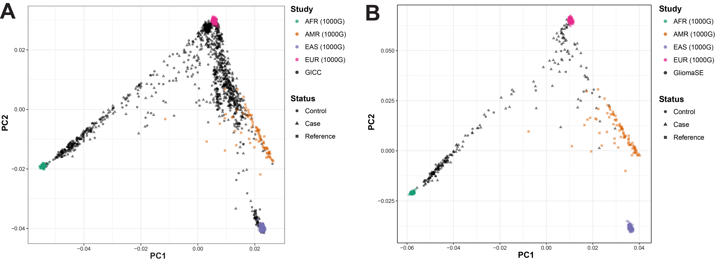

Supplementary Figure 2. Global ancestry estimates by self-identified race/ethnicity group for A) GliomaSE ((Self-identified African Americans and Hispanics), and B) GICC (individuals with European ancestry estimated to be <80% by FastPop in GICC)
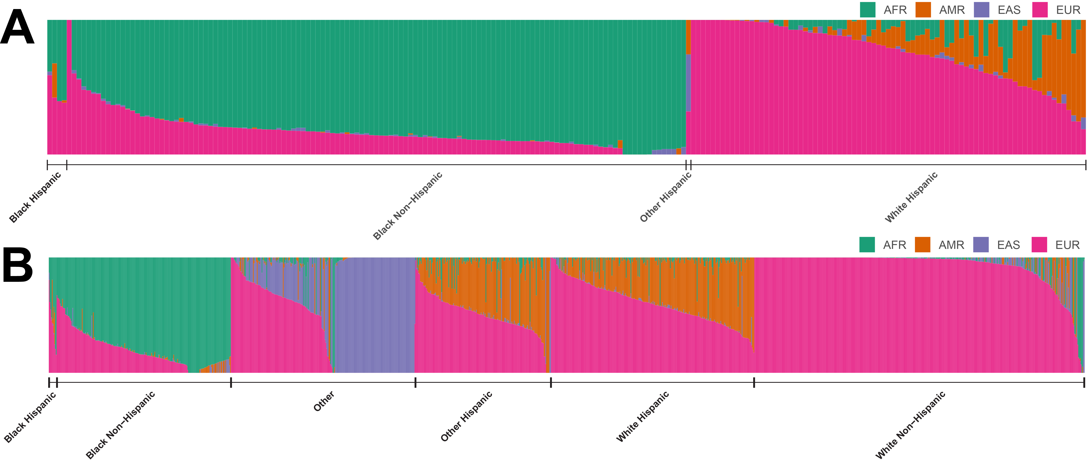

Supplementary Figure 3. Distribution of estimated proportion of global African ancestry in self-identified African-Americans, and of estimated proportion of native American ancestry in self-identified Hispanics

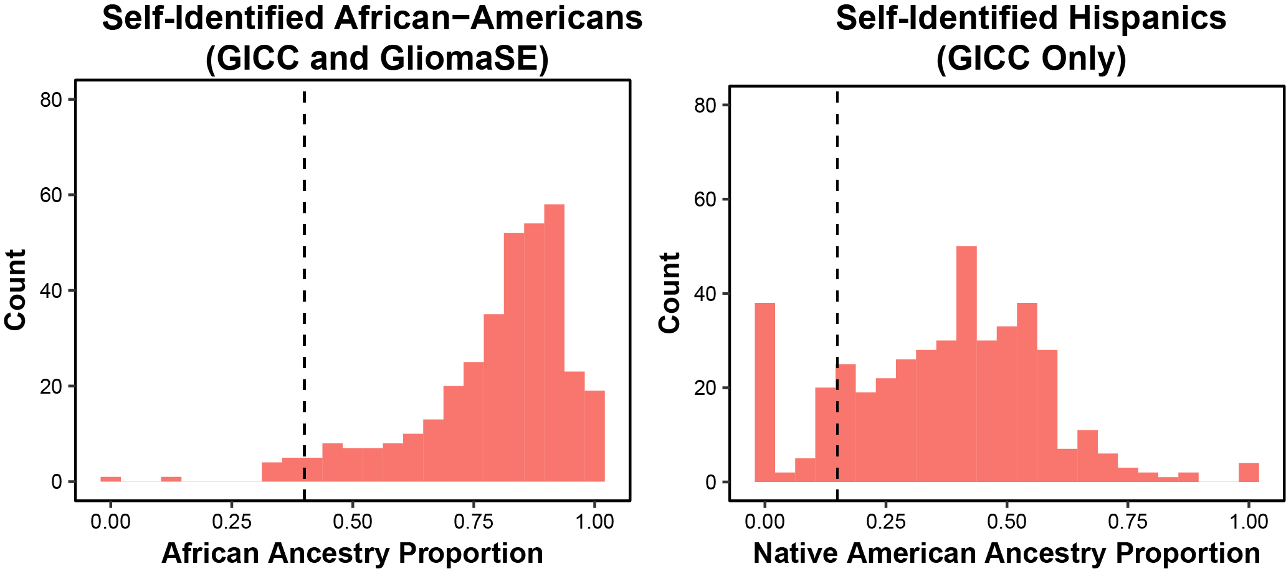

Supplementary Figure 4. Distributions and p-values for A) global European Ancestry and B) global African Ancestry overall, and by study site for C) global European Ancestry and D) global African Ancestry, among those for those self-identified as African American
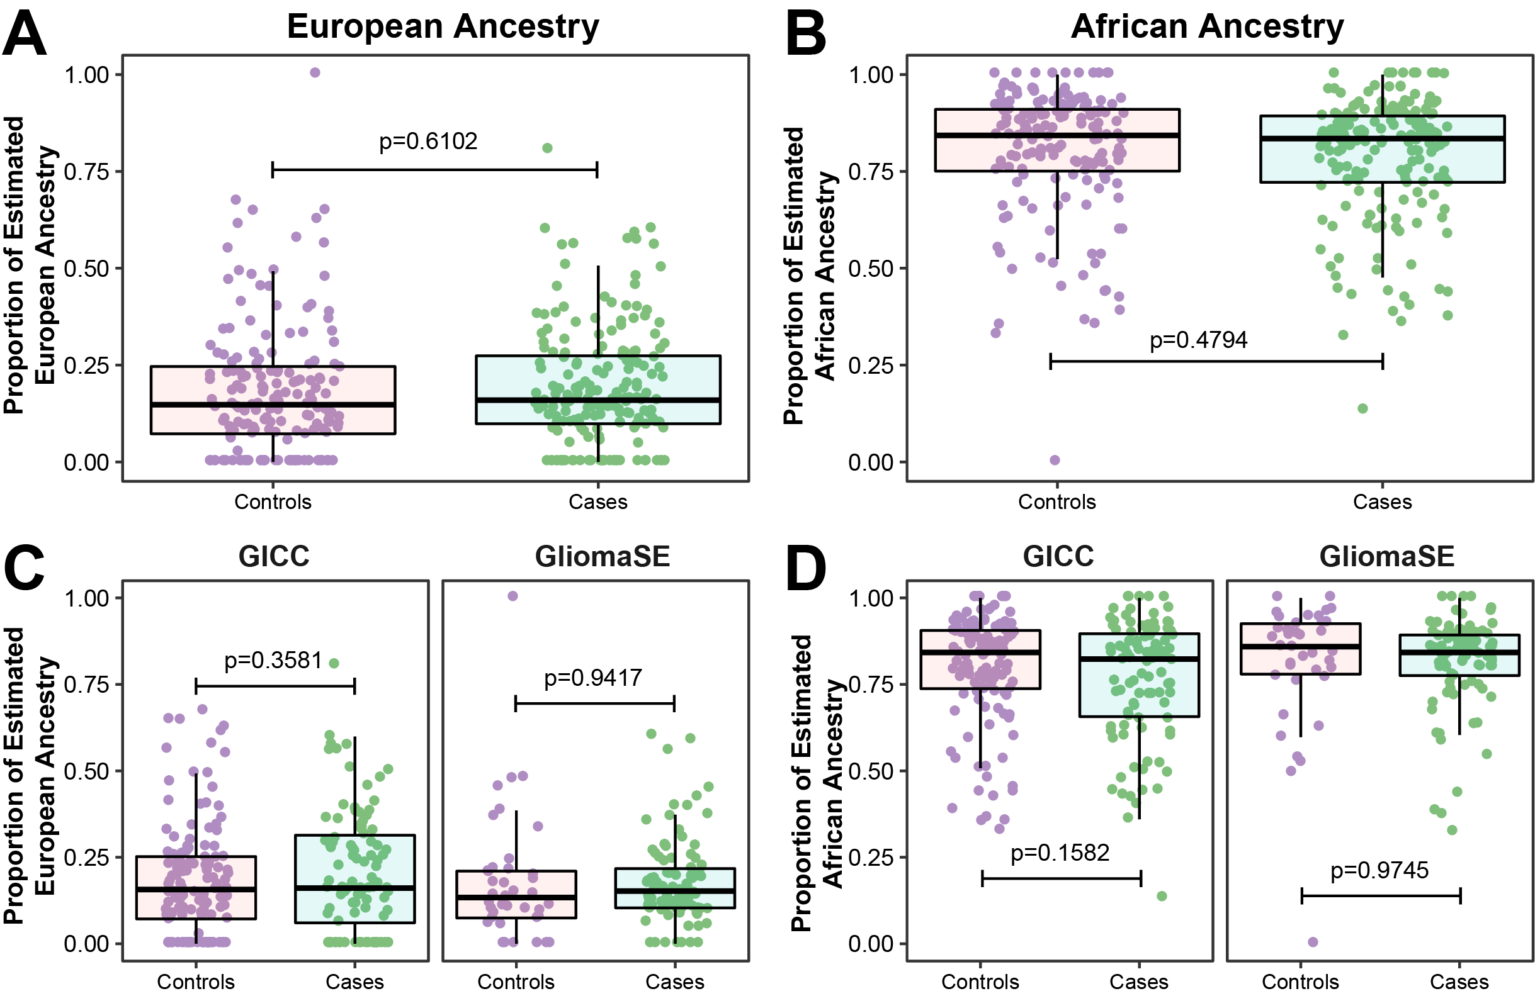

Supplementary Figure 5. Distributions and p-values for global European Ancestry and global African Ancestry by histology for those self-identified as African American

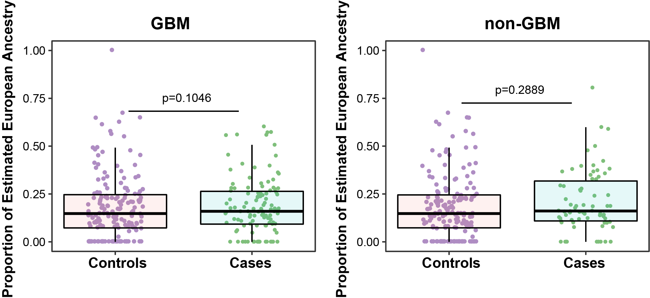

Supplementary Figure 6. Distributions and p-values for A) global European Ancestry and B) global Native American Ancestry overall, and by study site for C) global European Ancestry and D) global Native American Ancestry, among those self-identified as Hispanic
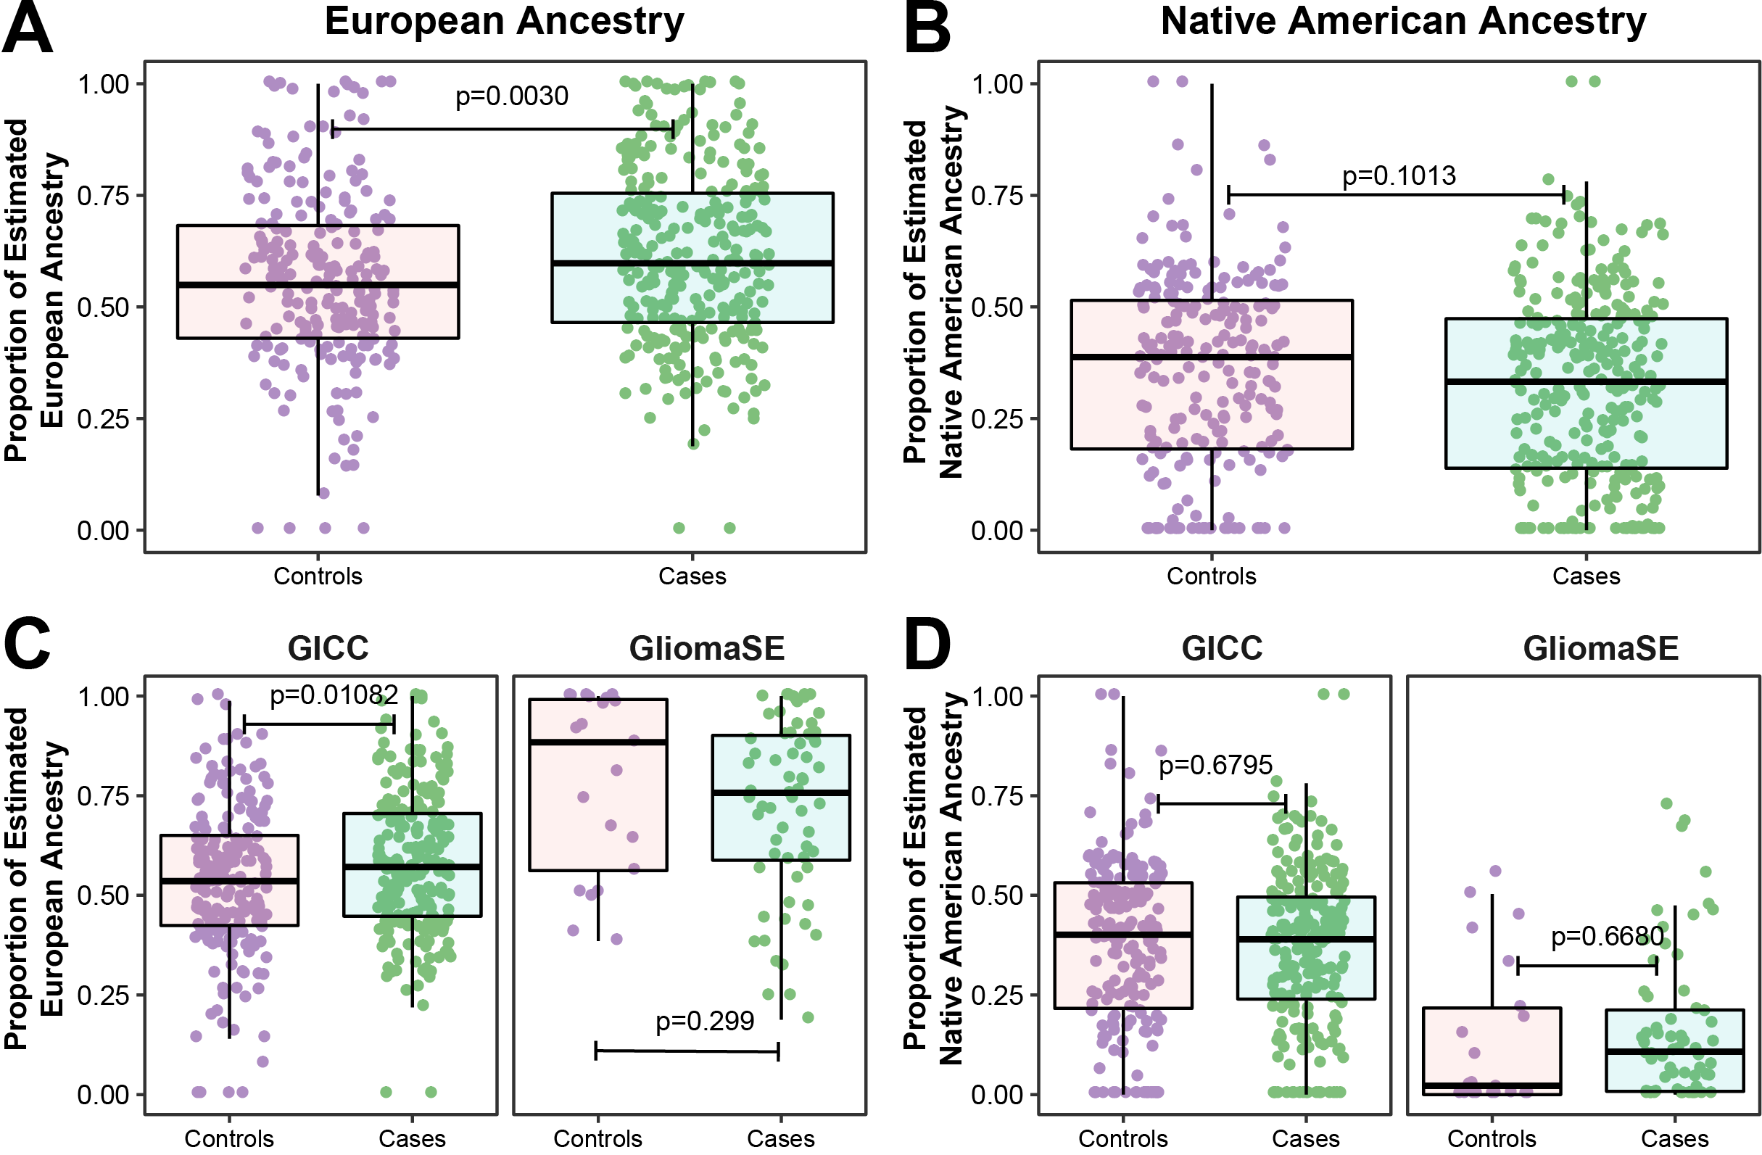

Supplementary Figure 7. Distributions and p-values for global European Ancestry and global Native American Ancestry by histology for those self-identified as Hispanic
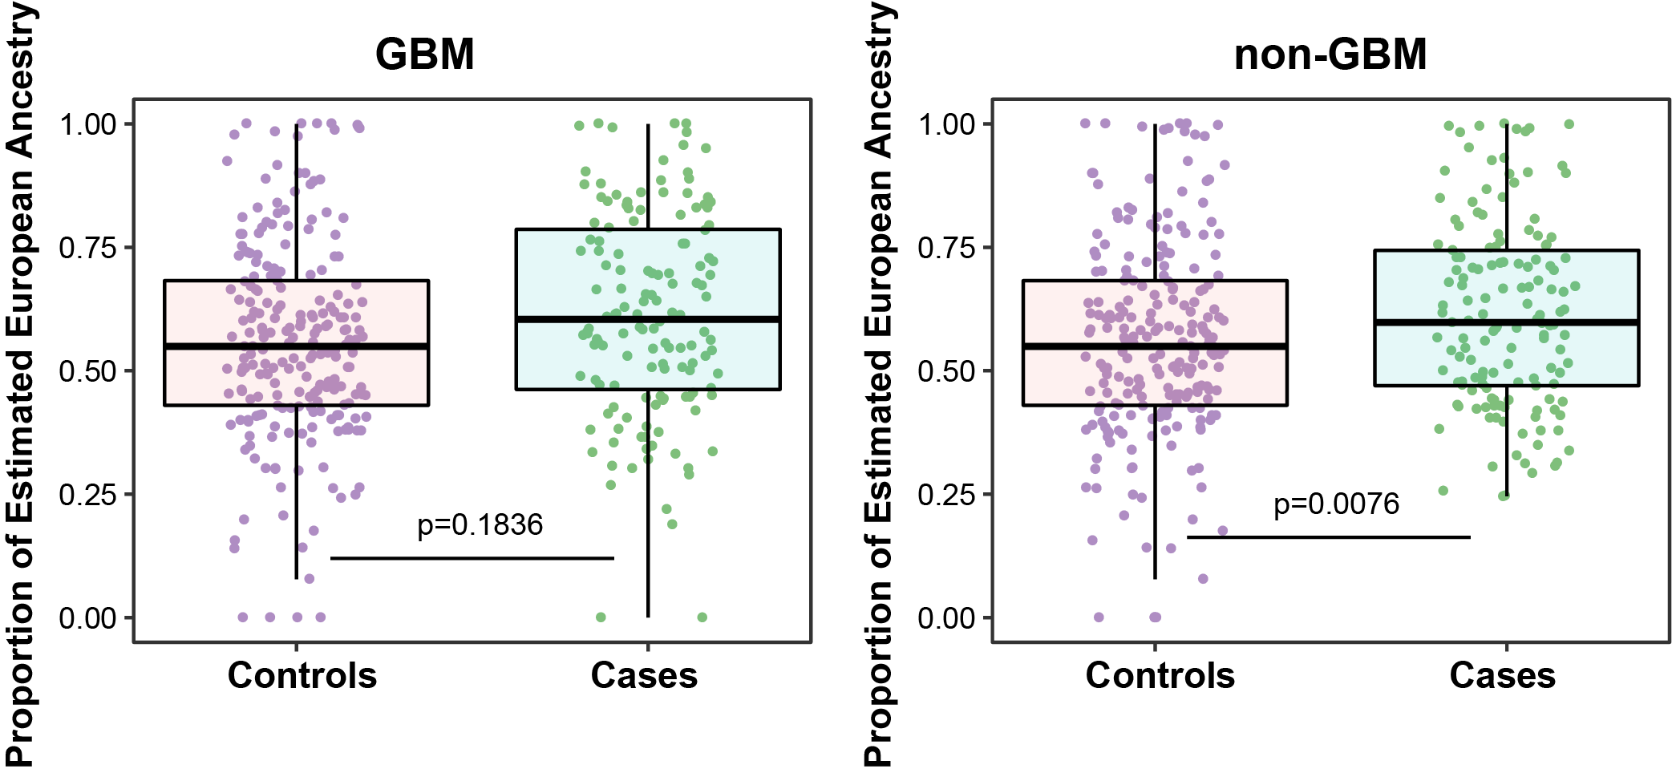

Supplementary Figure 8. -log10(p) values for single SNP associations in individuals with >=40% global African ancestry (AFR_{≥0.4} ) for selected regions on A) chromosome 7, B) chromosome 11, and C) chromosome 20, and individuals with >=15% global Native American ancestry (AMR_{≥0.15}) for selected regions one D) chromosome 8, E) chromosome 12, and F) chromosome 20.


