Supplementary Table 1 Demographic characteristics of included GWAS studies
Characteristic | Study | Males |  | Females
 |  | Cases | Controls | Cases | Controls
N | Total | 4,831 | 5,216 | 3,206 | 5,470
 | GICCª | 2,733 | 1,868 | 1,831 | 1,397
 | SFAGS-GWAS^{b} | 440 | 749 | 237 | 1,611
 | MDA-GWAS^{c} | 714 | 1,094 | 429 | 1,142
 | Gliomascan^{d} | 944 | 1,465 | 709 | 1,260
Mean Age (SD) | Total | 52.5 (14.5) | 58.2 (15.2) | 51.8 (14.9) | 54.7 (14.5)
 | GICC | 52.5 (14.3) | 56.1 (13.4) | 51.3 (14.6) | 53.4 (14.3)
 | SFAGS-GWAS | 53.8 (13.0) | 50.6 (14.8) | 53.5 (14.0) | 49.3 (13.2)
 | MDA-GWAS | 47.1 (13.0) | Modal age group: 60-69e | 47.7 (13.9) | Modal age group: 65-69^{f}
 | Gliomascan | 56.0 (15.5) | 69.3 (12.7) | 55.1 (15.7) | 64.0 (15.4)
GBM (% of total) | Total | 2,835 (58.7%) | -- | 1,682 (52.5%) | --
 | GICC | 1,575 (57.6%) | -- | 885 (48.3%) | --
 | SFAGS-GWAS | 333 (75.7%) | -- | 178 (75.1%) | --
 | MDA-GWAS | 397 (55.6%) | -- | 246 (57.3%) | --
 | Gliomascan | 530 (56.1%) | -- | 373 (52.6%) | --
GBM - Mean Age (SD) | Total | 57.3 (12.0) | -- | 57.8 (12.1) | --
 | GICC | 57.7 (11.4) | -- | 57.8 (11.6) | --
 | SFAGS-GWAS | 56.4 (11.5) | -- | 56.2 (12.3) | --
 | MDA-GWAS | 52.0 (11.7) | -- | 53.7 (11.3) | --
 | Gliomascan | 60.4 (13.0) | -- | 61.4 (12.5) | --
a. Data from Glioma International Case-Control Study (GICC; Melin, et al.¹)
b. Data from San Francisco Adult Glioma Study GWAS (SFAGS-GWAS; Wrensch, et al.²)
c. data from MD Anderson Cancer Center GWAS (MDA-GWAS; Shete, et al.³)
d. Data from the National Cancer Institute’s Gliomascan (Gliomascan; Rajaraman, et al.⁴);
e. Data from CGEMS prostate study (Yeager et al. ⁵). Continuous age is not available, age distribution is as follows 50-59: 12.3%, 60-69: 56.7%, 70-79: 30.7%, 80-89: 0.3%;
f. Data from CGEMS breast study (Hunter et al. ⁶). Continuous age is not available, age distribution is as follows: 0-54: 4.3%, 55-59: 15.0%, 60-64: 23.6%, 65-69: 27.5%, 70-74: 19.0%, 75-99: 10.7%.

Supplementary Table 2 Gene scores in males for prioritized genes by algorithm and histology
Gene (location) | Histology | Discovery |  |  |  | Validation
 |  | Pascal | BimBam | GATES | Algorithms p <3.3x10⁻⁶ | Pascal | BimBam | GATES | Algorithms p <0.001
BPESC1 (3q23) | All glioma | 0.1628 | 0.3621 | 1.0000 | 0/3 | 0.8506 | 1.0000 | 1.0000 | 0/3
 | Glioblastoma | 0.2889 | 0.7328 | 1.0000 | 0/3 | 0.3963 | 0.3103 | 0.3744 | 0/3
SLC6A18 (5p15.33) | All glioma | 4.08x10⁻¹⁰ | ≤1.00x10⁻⁶ | 3.26x10⁻¹³ | 3/3 | 1.78x10⁻¹¹ | ≤1.00x10⁻⁶ | 3.81x10⁻¹⁵ | 3/3
 | Glioblastoma | 1.00x10⁻¹² | ≤1.00x10⁻⁶ | 1.20x10⁻¹⁷ | 3/3 | 1.34x10⁻¹¹ | ≤1.00x10⁻⁶ | 4.88x10⁻¹⁵ | 3/3
TERT (5p15.33) | All glioma | 6.92x10⁻⁸ | ≤1.00x10⁻⁶ | 4.99x10⁻¹³ | 3/3 | 4.21x10⁻⁹ | ≤1.00x10⁻⁶ | 6.00x10⁻¹⁵ | 3/3
 | Glioblastoma | 1.69x10⁻¹⁰ | ≤1.00x10⁻⁶ | 1.84x10⁻¹⁷ | 3/3 | 7.20x10⁻¹⁰ | ≤1.00x10⁻⁶ | 7.67x10⁻¹⁵ | 3/3
EGFR (7p11.2) | All glioma | 1.00x10⁻¹² | ≤1.00x10⁻⁶ | 2.60x10⁻⁹ | 3/3 | 6.63x10⁻⁶ | 4.99x10⁻⁴ | 6.15x10⁻⁴ | 3/3
 | Glioblastoma | 1.00x10⁻¹² | ≤1.00x10⁻⁶ | 7.75x10⁻⁹ | 3/3 | 4.84x10⁻⁷ | 1.45x10⁻⁴ | 2.04x10⁻⁴ | 3/3
CDKN2B (9p21.3) | All glioma | 1.00x10⁻¹² | ≤1.00x10⁻⁶ | 3.65x10⁻¹³ | 3/3 | 1.04x10⁻⁸ | ≤1.00x10⁻⁶ | 2.41x10⁻⁸ | 3/3
 | Glioblastoma | 1.00x10⁻¹² | ≤1.00x10⁻⁶ | 4.54x10⁻¹³ | 3/3 | 4.81x10⁻⁹ | ≤1.00x10⁻⁶ | 2.87x10⁻⁸ | 3/3
DNAH2 (17p13.1) | All glioma | 7.21x10⁻⁴ | ≤1.00x10⁻⁶ | 4.01x10⁻⁷ | 2/3 | 7.64x10⁻⁶ | ≤1.00x10⁻⁶ | 4.11x10⁻⁸ | 3/3
 | Glioblastoma | 0.0023 | 3.76x10⁻⁵ | 7.94x10⁻⁶ | 0/3 | 9.60x10⁻⁵ | 2.00x10⁻⁶ | 7.88x10⁻⁷ | 3/3
STMN3 (20q13.33) | All glioma | 8.96x10⁻¹⁰ | ≤1.00x10⁻⁶ | 4.37x10⁻⁸ | 3/3 | 9.90x10⁻¹² | ≤1.00x10⁻⁶ | 2.03x10⁻¹¹ | 3/3
 | Glioblastoma | 3.96x10⁻¹¹ | ≤1.00x10⁻⁶ | 2.94x10⁻⁹ | 3/3 | 1.13x10⁻⁹ | ≤1.00x10⁻⁶ | 9.53x10⁻⁹ | 3/3
RTEL1-TNFRSF6B  (20q13.33) | All glioma | 6.42x10⁻¹⁰ | ≤1.00x10⁻⁶ | 4.71x10⁻⁸ | 3/3 | 1.00x10⁻¹² | ≤1.00x10⁻⁶ | 2.18x10⁻¹¹ | 3/3
 | Glioblastoma | 7.59x10⁻¹¹ | ≤1.00x10⁻⁶ | 3.17x10⁻⁹ | 3/3 | 9.19x10⁻¹¹ | ≤1.00x10⁻⁶ | 1.02x10⁻⁸ | 3/3
Abbreviations: BPESC1: blepharophimosis, epicanthus inversus and ptosis, candidate 1 (non-protein coding); SLC6A18: solute carrier family 6 member 18; TERT: telomerase reverse transcriptase; EGFR: epidermal growth factor receptor; CDKN2B-AS1: CDKN2B antisense RNA 1; CDKN2B: cyclin dependent kinase inhibitor 2B; DNAH2: dynein axonemal heavy chain 2; STMN3: stathmin 3; RTEL1-TNFRSF6B: RTEL1-TNFRSF6B readthrough (NMD candidate).

Supplementary Table 3 Gene scores in females for prioritized genes by algorithm and histology
Gene (location) | Histology | Discovery |  |  |  | Validation
 |  | Pascal | BimBam | GATES | Algorithms p <3.3x10⁻⁶ | Pascal | BimBam | GATES | Algorithms p <0.001
BPESC1 (3q23) | All glioma | 9.42x10⁻⁶ | 1.08x10⁻⁵ | 2.36x10⁻⁵ | 0/3 | 0.4891 | 1.0000 | 1.0000 | 0/3
 | Glioblastoma | 7.69x10⁻⁷ | 2.00x10⁻⁶ | 1.73x10⁻⁶ | 3/3 | 0.8286 | 1.0000 | 1.0000 | 0/3
SLC6A18 (5p15.33) | All glioma | 5.57x10⁻⁹ | ≤1.00x10⁻⁶ | 1.91x10⁻¹¹ | 3/3 | 1.29x10⁻⁸ | ≤1.00x10⁻⁶ | 7.43x10⁻¹⁰ | 3/3
 | Glioblastoma | 1.45x10⁻¹⁰ | ≤1.00x10⁻⁶ | 1.20x10⁻¹⁴ | 3/3 | 3.27x10⁻⁷ | ≤1.00x10⁻⁶ | 2.68x10⁻⁹ | 3/3
TERT (5p15.33) | All glioma | 1.69x10⁻⁷ | ≤1.00x10⁻⁶ | 2.93x10⁻¹¹ | 3/3 | 4.33x10⁻⁹ | ≤1.00x10⁻⁶ | 1.17x10⁻⁹ | 3/3
 | Glioblastoma | 1.41x10⁻⁸ | ≤1.00x10⁻⁶ | 1.83x10⁻¹⁴ | 3/3 | 2.97x10⁻⁸ | ≤1.00x10⁻⁶ | 4.21x10⁻⁹ | 3/3
EGFR (7p11.2) | All glioma | 5.85x10⁻⁴ | 0.0023 | 0.0085 | 0/3 | 0.0031 | 0.0112 | 0.0331 | 0/3
 | Glioblastoma | 1.38x10⁻⁵ | 1.44x10⁻⁴ | 1.35x10⁻⁴ | 0/3 | 2.56x10⁻⁵ | 0.0021 | 0.0065 | 1/3
CDKN2B (9p21.3) | All glioma | 7.42x10⁻⁷ | 4.00x10⁻⁶ | 4.98x10⁻⁶ | 1/3 | 7.51x10⁻⁸ | ≤1.00x10⁻⁶ | 5.35x10⁻⁷ | 3/3
 | Glioblastoma | 5.53x10⁻⁹ | ≤1.00x10⁻⁶ | 1.63x10⁻⁸ | 3/3 | 8.99x10⁻⁸ | ≤1.00x10⁻⁶ | 5.93x10⁻⁷ | 3/3
DNAH2 (17p13.1) | All glioma | 2.41x10⁻⁴ | 3.07x10⁻⁴ | 3.08x10⁻⁴ | 0/3 | 0.0012 | 7.75x10⁻⁶ | 1.96x10⁻⁶ | 2/3
 | Glioblastoma | 0.0036 | 0.0032 | 0.0067 | 0/3 | 0.0037 | 1.41x10⁻⁴ | 3.31x10⁻⁵ | 2/3
STMN3 (20q13.33) | All glioma | 2.12x10⁻⁸ | 2.00x10⁻⁶ | 4.17x10⁻⁶ | 2/3 | 6.21x10⁻⁶ | 2.00x10⁻⁶ | 2.69x10⁻⁶ | 3/3
 | Glioblastoma | 2.39x10⁻⁸ | 3.00x10⁻⁶ | 7.25x10⁻⁶ | 2/3 | 2.42x10⁻⁷ | ≤1.00x10⁻⁶ | 1.30x10⁻⁸ | 3/3
RTEL1-TNFRSF6B  (20q13.33) | All glioma | 9.64x10⁻⁸ | 1.02x10⁻⁵ | 1.14x10⁻⁵ | 1/3 | 6.04x10⁻⁷ | 2.00x10-6 | 2.89x10⁻⁶ | 3/3
 | Glioblastoma | 4.52x10⁻⁸ | 4.00x10⁻⁶ | 7.82x10⁻⁶ | 1/3 | 1.11x10⁻⁸ | ≤1.00x10⁻⁶ | 1.40x10⁻⁸ | 3/3
Abbreviations: BPESC1: blepharophimosis, epicanthus inversus and ptosis, candidate 1 (non-protein coding); SLC6A18: solute carrier family 6 member 18; TERT: telomerase reverse transcriptase; EGFR: epidermal growth factor receptor; CDKN2B-AS1: CDKN2B antisense RNA 1; CDKN2B: cyclin dependent kinase inhibitor 2B; DNAH2: dynein axonemal heavy chain 2; STMN3: stathmin 3; RTEL1-TNFRSF6B: RTEL1-TNFRSF6B readthrough (NMD candidate).

Supplementary Table 4 Conditional gene scores in males for prioritized genes by algorithm and histology
Gene | Histology | Discovery |  |  | Validation
 |  | Pascal | BimBam | GATES | Pascal | BimBam | GATES
SLC6A18ª | All glioma | 0.0947 | 0.0806 | 0.1093 | 0.2174 | 0.0123 | 0.0163
 | Glioblastoma | 0.1178 | 0.0169 | 0.0213 | 0.1178 | 0.0120 | 0.0156
TERTª | All glioma | 0.2761 | 0.0726 | 0.1538 | 0.6647 | 0.0236 | 0.0262
 | Glioblastoma | 0.4487 | 0.0233 | 0.0326 | 0.4487 | 0.0146 | 0.0252
EGFR^{b} | All glioma | 0.0081 | 9.45x10⁻⁴ | 0.0016 | 0.0559 | 0.0013 | 0.0017
 | Glioblastoma | 0.0015 | 0.0004 | 0.0016 | 0.0295 | 0.0133 | 0.0865
CDKN2B^{c} | All glioma | 0.3343 | 0.2419 | 0.2336 | 0.4163 | 0.3065 | 0.3226
 | Glioblastoma | 0.2599 | 0.0124 | 0.0751 | 0.2599 | 0.1452 | 0.2118
DNAH2^{d} | All glioma | 0.0666 | 0.0565 | 0.3101 | 0.7448 | 0.9758 | 1.0000
 | Glioblastoma | 0.5835 | 0.5161 | 1.0000 | 0.5835 | 0.6694 | 0.4353
STMN3e | All glioma | 0.0033 | 0.0070 | 0.0093 | 0.0303 | 8.25x10⁻⁴ | 0.0011
 | Glioblastoma | 0.0053 | 0.0060 | 0.0133 | 0.0063 | 0.0071 | 0.0080
RTEL1-TNFRSF6B^{e} | All glioma | 0.0069 | 0.0041 | 0.0101 | 0.0174 | 0.0015 | 0.0012
 | Glioblastoma | 0.0082 | 0.0067 | 0.0143 | 0.0101 | 0.0087 | 0.0086
Abbreviations: BPESC1: blepharophimosis, epicanthus inversus and ptosis, candidate 1 (non-protein coding); SLC6A18: solute carrier family 6 member 18; TERT: telomerase reverse transcriptase; EGFR: epidermal growth factor receptor; CDKN2B-AS1: CDKN2B antisense RNA 1; CDKN2B: cyclin dependent kinase inhibitor 2B; DNAH2: dynein axonemal heavy chain 2; STMN3: stathmin 3; RTEL1-TNFRSF6B: RTEL1-TNFRSF6B readthrough (NMD candidate).
a. conditioned on rs10069690 (TERT)
b. conditioned on rs75061358, rs723527, and rs11979158 (EGFR)
c. conditioned on rs634537
d. conditioned on rs78378222 (TP53)
e. conditioned on rs2297440 (RTEL1)

Supplementary Table 5 Conditional gene scores in females for prioritized genes by algorithm and histology
Gene | Histology | Discovery |  |  | Validation
 |  | Pascal | BimBam | GATES | Pascal | BimBam | GATES
SLC6A18 ª | All glioma | 0.0130 | 0.0021 | 0.0012 | 0.0119 | 0.0140 | 0.0196
 | Glioblastoma | 0.0361 | 0.0002 | 0.0004 | 0.0361 | 0.0032 | 0.0041
TERT ª | All glioma | 0.0412 | 0.0017 | 0.0018 | 0.0053 | 0.0051 | 0.0189
 | Glioblastoma | 0.0065 | 7.16x10⁻⁴ | 5.86x10⁻⁴ | 0.0065 | 0.0046 | 0.0067
EGFR^{b} | All glioma | 0.0896 | 0.0565 | 0.1152 | 0.0397 | 0.0645 | 0.3248
 | Glioblastoma | 0.0723 | 0.0484 | 0.1274 | 0.0123 | 0.0806 | 0.6290
CDKN2B ^{c} | All glioma | 0.5988 | 1.0000 | 1.0000 | 0.0061 | 0.0089 | 0.0249
 | Glioblastoma | 0.0010 | 0.8468 | 1.0000 | 0.0010 | 0.0010 | 0.0033
DNAH2^{d} | All glioma | 0.3671 | 0.5645 | 0.6547 | 0.5484 | 0.6613 | 1.0000
 | Glioblastoma | 0.5758 | 0.2903 | 0.2693 | 0.5758 | 0.7016 | 1.0000
STMN3e | All glioma | 8.91x10⁻⁴ | 0.0042 | 0.0128 | 0.0290 | 0.0078 | 0.0278
 | Glioblastoma | 0.0022 | 0.0032 | 0.0194 | 0.0805 | 0.0132 | 0.0368
RTEL1-TNFRSF6B^{e} | All glioma | 0.0019 | 0.0023 | 0.0094 | 0.0415 | 0.0135 | 0.0300
 | Glioblastoma | 0.0036 | 0.0044 | 0.0195 | 0.0777 | 0.0122 | 0.0397
Abbreviations: BPESC1: blepharophimosis, epicanthus inversus and ptosis, candidate 1 (non-protein coding); SLC6A18: solute carrier family 6 member 18; TERT: telomerase reverse transcriptase; EGFR: epidermal growth factor receptor; CDKN2B-AS1: CDKN2B antisense RNA 1; CDKN2B: cyclin dependent kinase inhibitor 2B; DNAH2: dynein axonemal heavy chain 2; STMN3: stathmin 3; RTEL1-TNFRSF6B: RTEL1-TNFRSF6B readthrough (NMD candidate).
a. conditioned on rs10069690 (TERT)
b. conditioned on rs75061358, rs723527, and rs11979158 (EGFR)
c. conditioned on rs634537
d. conditioned on rs78378222 (TP53)
e. conditioned on rs2297440 (RTEL1)

SUPPLEMENTARY FIGURES

Supplementary Figure 1 Average Annual Incidence of all glioma and glioblastoma by Sex and Age at diagnosis (CBTRUS 2010-2014)
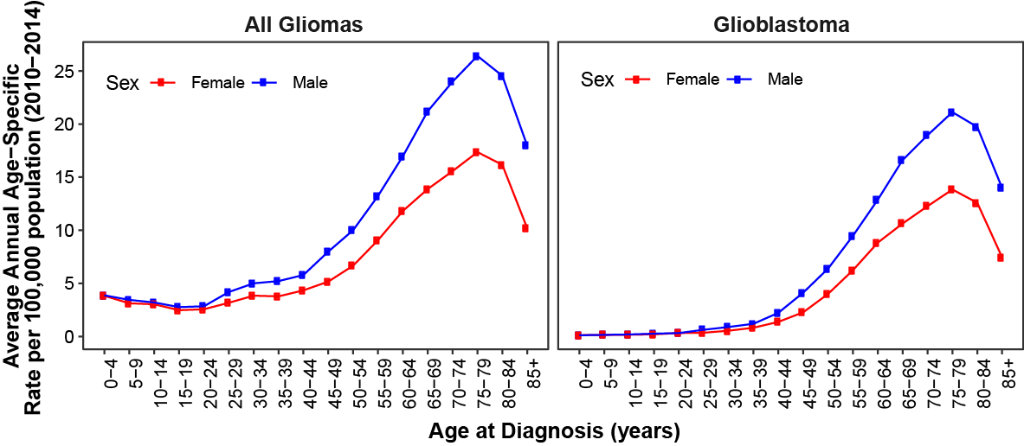

Supplementary Figure 2. Single SNP associations within EGFR after conditioning on 75061358, rs723527, and rs11979158 in a meta-analysis of all four studies for all glioma in a) males, and b) females, and for glioblastoma in c) males and d) females.
Supplementary Figure 3. Single SNP associations within TERT after conditioning on rs10069690 in a meta-analysis of all four studies for all glioma in a) males, and b) females, and for glioblastoma in c) males and d) females.
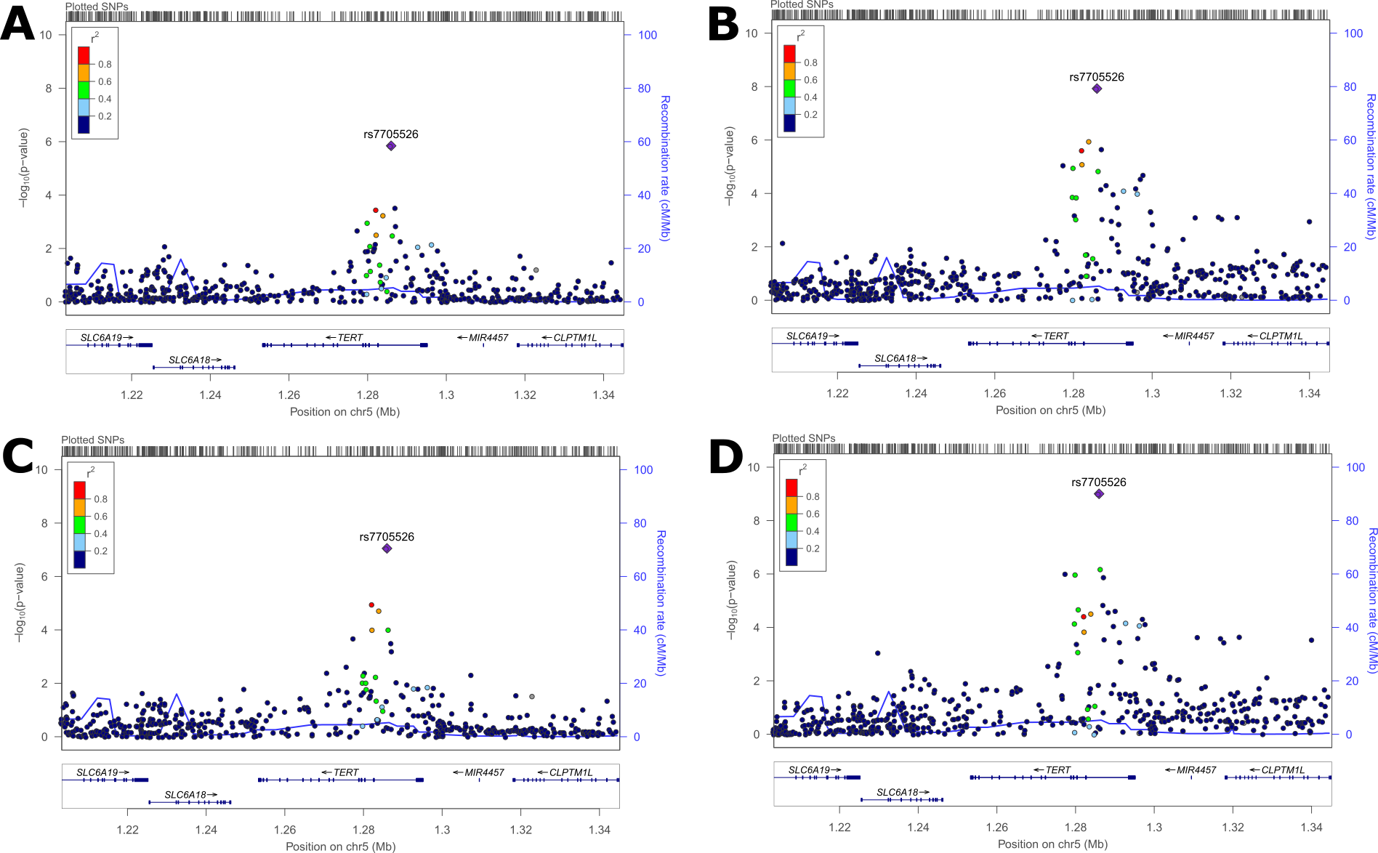

Supplementary Figure 4. Single SNP associations within RTEL1-TNFRSF6B after conditioning on rs2297440 in a meta-analysis of all four studies for all glioma in a) males, and b) females, and for glioblastoma in c) males and d) females.

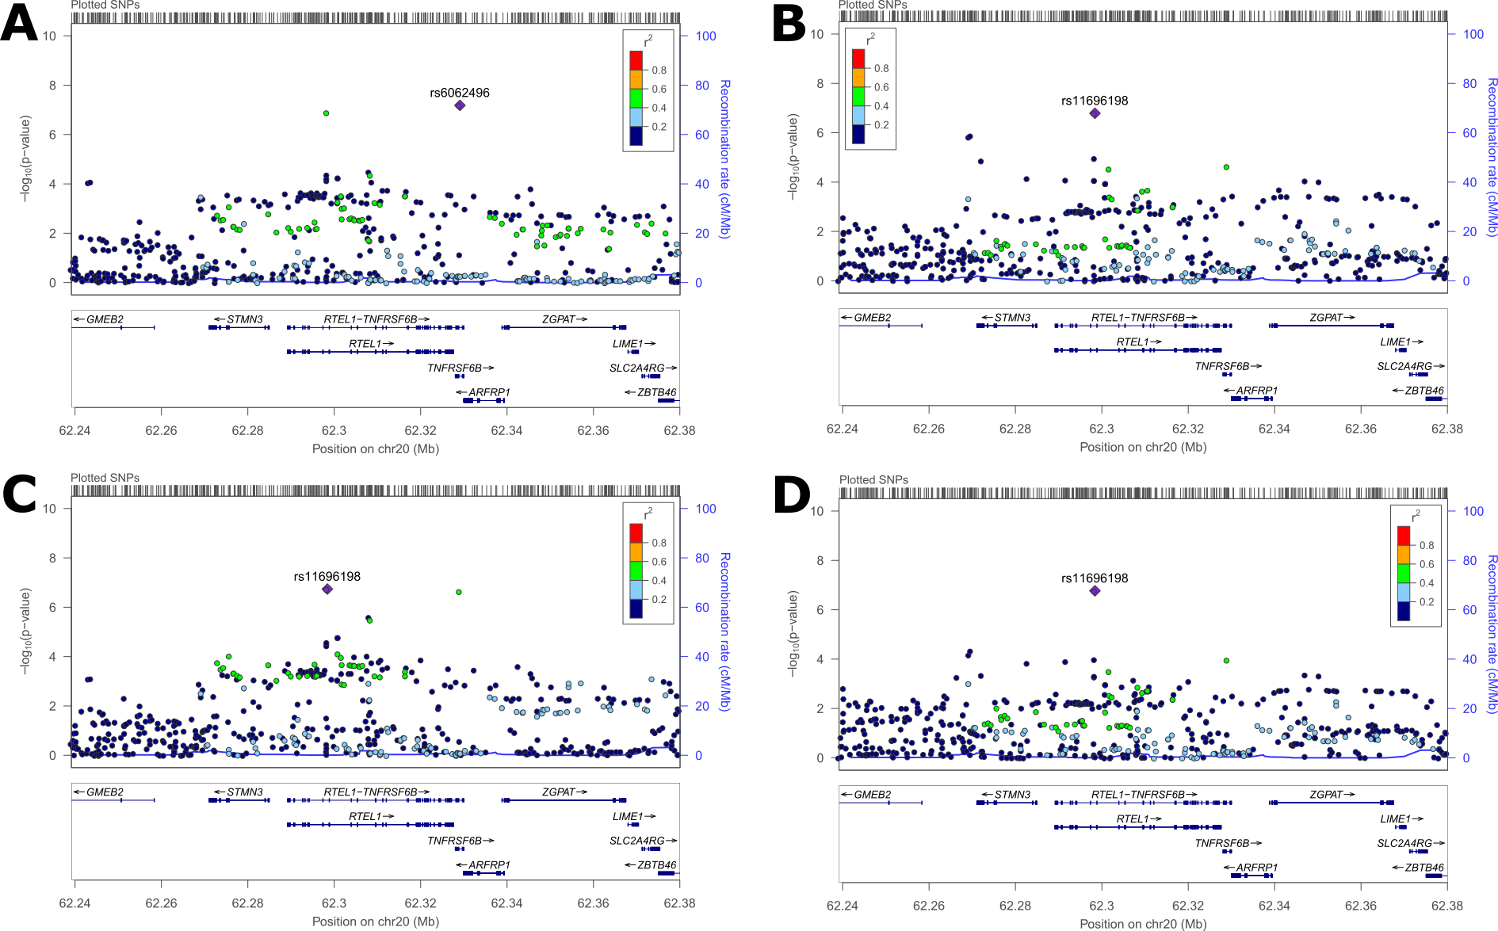

Supplementary Figure 5. Sex-specific odds ratios, 95% confidence intervals, and p-values for most significant SNPs in conditional logistic regressions by histology in A) TERT and B) TNFRSF6B
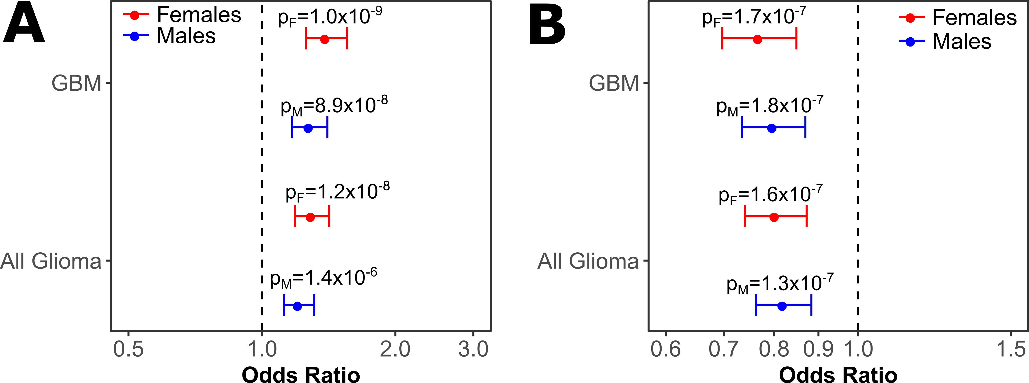
Supplementary Figure 6. Gene-scores for genes in the glioma pathway (KEGG) for all glioma in a) males, and b) females, and for glioblastoma in c) males and d) females.

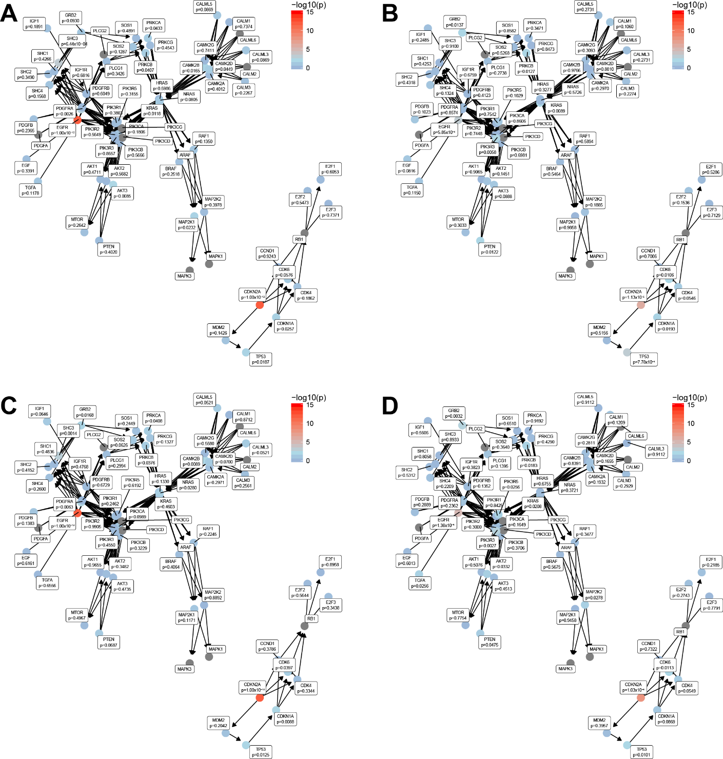

Supplementary Figure 7. Gene-scores for genes in the melanoma pathway (KEGG) for all glioma in a) males, and b) females, and for glioblastoma in c) males and d) females.
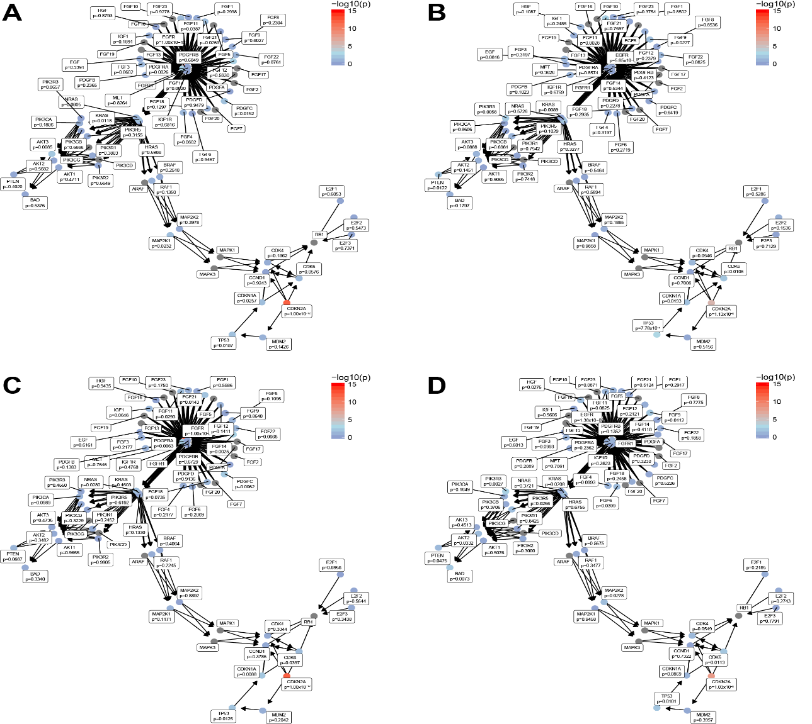

Supplementary Figure 8. Overlap of genes containing SNPs with nominally significant glioma associations by identified KEGG pathways
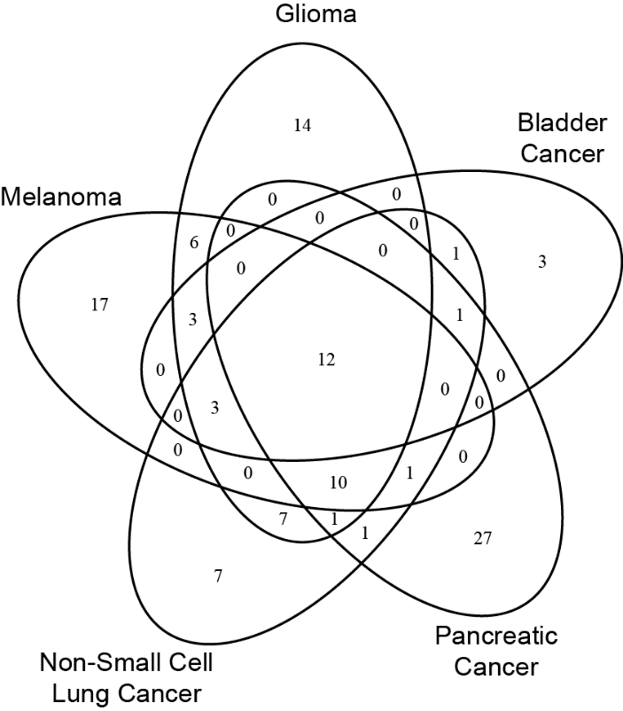

References

1. Melin BS, Barnholtz-Sloan JS, Wrensch MR, et al. Genome-wide association study of glioma subtypes identifies specific differences in genetic susceptibility to glioblastoma and non-glioblastoma tumors. Nat. Genet. 2017; 49(5):789-794.
2. Wrensch M, Jenkins RB, Chang JS, et al. Variants in the CDKN2B and RTEL1 regions are associated with high-grade glioma susceptibility. Nature genetics. 2009; 41(8):905-908.
3. Shete S, Hosking FJ, Robertson LB, et al. Genome-wide association study identifies five susceptibility loci for glioma. Nature genetics. 2009; 41(8):899-904.
4. Rajaraman P, Melin BS, Wang Z, et al. Genome-wide association study of glioma and meta-analysis. Human Genetics 2012; 131(12):1877-1888.
5. Yeager M, Chatterjee N, Ciampa J, et al. Identification of a new prostate cancer susceptibility locus on chromosome 8q24. Nature genetics. 2009; 41(10):1055-1057.
6. Hunter DJ, Kraft P, Jacobs KB, et al. A genome-wide association study identifies alleles in FGFR2 associated with risk of sporadic postmenopausal breast cancer. Nature genetics. 2007; 39(7):870-874.

